Chemistry

Mandatory Experiments
Summary
+ Questions

2014/15

Leaving Certificate 2014/15 Mandatory Experiments

Syllabus  section | Title -  click on the experiment title to go straight to the summary of the experiment
1.1 | Flame tests
1.2 | Redox reactions of Group VII elements.  Halogens as oxidising agents with bromides, iodides, Iron(II) and sulphites
 | Displacement reactions of metals
2.1 | Tests for anions in aqueous solutions:
3.1 | Determination of the relative molecular mass of a volatile liquid
4.1 | Preparation of a standard solution of sodium carbonate
4.2 | Standardisation of a hydrochloric acid solution
4.2a | Hydrochloric acid / Sodium hydroxide titration and use of this reaction to make salt NaCl
4.3 | Determination of the concentration of ethanoic acid in vinegar
4.4 | Determination percentage water of crystallisation in a sample of hydrated sodium carbonate
4.5 | A potassium manganate (VII) / ammonium iron(II) sulphate titration
4.6 | Determination of the amount of iron in an iron tablet
4.7 | An iodine \ thiosulphate titration
4.8 | Determination of the percentage of hypochlorite in bleach
5.1 | Determination of the heat of reaction of hydrochloric acid with sodium hydroxide
5.2 | Preparation and properties of ethyne
6.1 | Monitoring the rate of production of oxygen from hydrogen peroxide using MnO₂
6.2 | Effect of concentration on reaction rate using sodium thiosulphate and hydrochloric acid.
6.2a | Effect of temperature on reaction rate using sodium thiosulphate and hydrochloric acid.
7.1 | Recrystallisation of benzoic acid and determination of its melting point
7.2 | Preparation of soap
7.3 | Preparation_and_Properties_of_ethene
7.4 | Preparation and properties of ethanal
7.5 | Preparation and properties of ethanoic acid
7.6 | Extraction of clove oil from cloves [or similar] by stem distillation
7.7 | Separation of a mixture of indicators using paper, thin layer or column chromatography
8.1 | Simple experiments to Illustrate Le Chatelier’s Principle
8.1a | To show effects of concentration changes on the equilibrium mixture
9.1 | Colorimetric experiment to estimate free chlorine in swimming pool water or bleach
9.2 | Determination of total suspended and dissolved solids in p.p.m.
9.2a | Determination of pH
9.3 | Estimation of total hardness using ethylenediaminetetraacetic acid. [edta]
9.4 | Estimation of dissolved oxygen by redox titration

VOLUMETRIC EXPERIMENTS

1. Preparing a Standard solution of Sodium Carbonate

- Weigh out approx 3g g of anhydrous Na₂CO₃ on a clock glass (M_{r} = 106g)
- Place in beaker with 100 ml deionised water with washings
- Stir to dissolve
- Place into 250 ml volumetric flask with washings
- Make up to mark with deionised water
- On level surface with bottom of meniscus and eye level with mark
- Invert 20 times to make homogeneous
- Label

(i) What is a standard solution?
A solution whose concentration is accurately known.

(ii) Why is it possible to make up a standard solution of sodium carbonate directly?
Because Na₂CO₃ is a primary standard, i.e. very pure and stable.

In this experiment:
(i) What precaution is taken to ensure that all of the sodium carbonate is transferred from the clock glass to the beaker?
The clock glass is rinsed with deionised water, and these rinsings are transferred to the beaker.

(ii) Why is a stirring rod used?
To speed up dissolving of the sodium carbonate, and to prevent the formation of hard lumps of the substance.

(iii) Why is it necessary to wash the solution off the stirring rod into the beaker?
To ensure that none of the sodium carbonate solution is lost

(iv) Why are the rinsings from the beaker added to the volumetric flask?
To ensure that all of the sodium carbonate solution is transferred to the volumetric flask.

(v) Why is it necessary to be particularly careful when adding the last few drops of water to the volumetric flask?
There is a danger of ‘overshooting’ the mark, resulting in a solution of unknown concentration. If this occurs, the experiment will have to be started again.

(vi) When the solution has been made up, why is it necessary to mix the contents of the flask thoroughly? What feature of the volumetric flask makes this particularly necessary?
To ensure a homogeneous solution.
The narrow neck of the flask.

(vii) Why is a beaker, rather than a conical flask, used when the solute is being dissolved?
The beaker has a spout which facilitates pouring, and stirring is easier because it does not have a narrow neck.

(viii) Why is a funnel used in transferring the solution from the beaker to the volumetric flask?
To minimise the risk of any spillage.

(ix) Why is it necessary to slowly add the solid sodium carbonate, with stirring, to the water in the beaker?

To prevent the formation of hard lumps of sodium carbonate. These lumps are quite difficult to dissolve.

2. To standardise a solution of HCl using a standard solution of Na₂CO₃

- Pipette 25 cm³ dil. HCl into a 250cm³ volumetric flask
- Make up to the mark with deionised water (dilutes acid to a factor of 10)
- Mix well to make homogeneous
- Pipette 20ml HCl into a conical flask
- Add methyl orange indicator [SAM] and note the colour
- Add Na₂CO₃ from burette
- Mix constantly
- Wash any drops from side with deionised water [doesn’t affect amount acid in flask]
- Note volume as indicator changes colour (red → orange)
- Do one rough and two accurate titres and take the average of two accurate
- Use V_{a}M_{a}/n_{a} = V_{b}M_{b}/n_{b} to solve
- Multiply answer by 10 to allow for dilution

- Why is a conical flask, rather than a beaker, used in the experiment?
To allow easy mixing of the contents, by swirling.

- Why is the funnel removed from the burette after adding the acid solution?
So that drops of solution from the funnel will not fall into the burette.

- In using a burette, why is it important (a) to rinse it with a little of the solution it is going to contain, (b) to clamp it vertically, (c) to have the part below the tap full?
  - To remove any residual water, and so avoid dilution of the acid solution when it is poured into the burette.
  - To enable the liquid level to be read correctly.
  - To ensure that the actual volume of liquid delivered into the conical flask is read accurately.

- The following procedures were carried out during the titration:
(a) The sides of the conical flask were washed down with deionised water.
  - The conical flask was frequently swirled or shaken.
Give one reason for carrying out each of these procedures.
  - To ensure that all of the acid added from the burette can react with the base.
  - To ensure complete mixing of the reactants.

- Why is a rough titration carried out?
To find the approximate end-point. This information enables the subsequent titrations to be carried out more quickly.

- Why is more than one accurate titration carried out?
To minimise error by getting accurate readings within 0.1 cm³ of each other.

- Explain why hydrochloric acid is not used as a primary standard.
The exact concentration of any hydrochloric acid solution is not known, unless it is prepared from standard ampoules. Laboratory grade hydrochloric acid is not sufficiently pure.

- Can any of the following be used as primary standards: NaOH, H₂SO₄, HNO₃? Explain your answer.
A primary standard should be available in a highly pure state and stable. None of these substances are available pure because (i)
NaOH readily absorbs water and carbon dioxide from the air
(ii) concentrated H₂SO₄ readily absorbs water from the air
(iii) HNO₃ breaks down, releasing NO₂ gas.

- If you used only 10cm³ of sodium carbonate solution in the conical flask, calculate how much acid would be required to neutralise it.
10 cm³ Na₂CO₃ solution used, at concentration of 0.1 M
=> 1 x 10⁻³ moles Na₂CO₃
=> 2 x 10⁻³ moles HCl required
Concentration of HCl is 0.19 M
1000 x 2 x 10⁻³ / 0.19 cm³ required = 10.5 cm³

- Describe, briefly, how a pure dry sample of sodium chloride could be obtained having carried out the titration.
Using the information provided by the titration results, add just enough hydrochloric acid to exactly neutralise 25 cm³ of sodium carbonate. The indicator should not be added. Gently heat the solution until all the water has evaporated to dryness. A sample of sodium chloride will remain in the beaker.

A hydrochloric acid/sodium hydroxide titration and the use of this titration in making the salt sodium chloride

1. Describe, briefly, the washing/rinsing procedure for the apparatus before starting the titration.
Rinse the burette, pipette and conical flask respectively with deionised water. Rinse
the burette with hydrochloric acid solution, and rinse the pipette with sodium
hydroxide solution.

2. Mention two other precautions that should be taken to ensure accuracy when using a pipette.

Make sure that it is filled exactly to the mark. Allow it to release its contents freely,
and then touch it to the inside of the conical flask for a few seconds.

3. Mention three operations that should be carried out during the titration to ensure an accurate titre.
Swirl the contents of the conical flask after each addition of acid to the conical flask.
Using a wash bottle, wash down with deionised water any solution adhering to the
sides of the conical flask. Take all burette readings at eye level.

4. Suggest another suitable indicator for this reaction. How would you test to see
whether your suggestion would work?
Methyl red (or phenolphthalein).
Repeat the experiment to see if the same result was obtained.

5. Why is it undesirable to put sodium hydroxide solution into the burette rather than in the conical flask?

If the burette is not washed out very thoroughly after use, sodium hydroxide may
crystallise in the Teflon tap causing blocking of the burette nozzle, or, at best,
changing the concentration of the delivered solution. (If a burette with a glass tap
is being used, the tap is likely to get stuck.)

6. Can you suggest a means of neutralising a (a) HCl and (b) HNO₃ acidic effluent
from a manufacturing process to enable it to be disposed of safely? Write the
chemical equations for the appropriate reactions.
Neutralise with NaOH solution.
HCl + NaOH → NaCl + H₂O
HNO₃ + NaOH → NaNO₃ + H₂O

3. To determine the percentage of Ethanoic acid in vinegar

- Pipette 20 ml NaOH into conical flask,
- Add a few drops of phenolphthalein indicator [WAP], turns pink.
- Put Ethanoic acid in burette (remove air bubble).
- Record initial volume
- Add to NaOH in flask
- When pink turns colourless note volume (adding dropwise near end).
- Do one rough and two accurate and take the average of two accurate
- Take account of dilution

- Why is the vinegar diluted?

To avoid a very small titre, which would reduce the accuracy of the experiment. Diluting the vinegar also reduces the amount of vinegar and the amount of sodium hydroxide solution needed in the experiment

- Outline the correct procedure for bringing the solution in the volumetric flask precisely to the 250 cm³ mark.
Fill the flask to within about 1 cm of the calibration mark, and then add the water
dropwise, using a dropping pipette, until the bottom of the meniscus just rests on
the calibration mark.

- Outline the procedure used in preparing the burette so that it is ready for the first titration.
Rinse the burette with deionised water, and then with diluted vinegar solution. Fill
the burette with diluted vinegar solution above the zero mark. Remove the funnel.
Using the tap at the base of the burette, allow the acid to flow into a beaker until
the level of liquid is at the zero mark. Ensure that there are no air bubbles in the
nozzle of the burette.

- Give two other precautions which should be taken to ensure that the burette readings are accurate.
Make sure that the burette is clamped vertically. Read the level of liquid in the burette by noting the lower level of the meniscus at eye level.

- Why is phenolphthalein used as the indicator in this titration?
Because this is a weak acid/strong base titration, and phenolphthalein is the only
one of the commonly used indicators that changes colour in the appropriate pH
range.

- Why is a rough titration carried out?
To find the approximate end-point. This information enables the subsequent
titrations to be carried out more quickly.

- What happens at the end point?
The indicator changes colour from pink to colourless.

4. To determine the percentage of water of crystallisation in hydrated
sodium carbonate (washing soda)

- weigh out 5g washing soda crystals [Na₂CO₃]
- dissolve in 100cm³ deionised water, stir
- transfer to 250 cm³ flask with washings, make solution up to mark, invert 20 times
- pipette 25cm³ of Sodium carbonate solution into conical flask
- add 3 drops of methyl orange indicator goes yellow [SAM]
- fill burette with HCl solution
- titrate: colour change from yellow to pink
- do one rough and 3 accurate – average of 2 accurate

Calculation - use: VaxMa = VbxMb
na nb
- Mass of anhydrous Na₂CO₃ = M x106
- mass of water = mass of crystals - mass of anhydrous Na₂CO₃ =
- % anhydrous Na₂CO₃ = mass of anhydrous Na₂CO₃ % water = mass of water
mass of crystals mass of crystals

- % anhydrous Na₂CO₃ : % water
106 18

- What was done to the volumetric flask and its contents immediately after the solution had been made up to the mark with deionised water? Why was it important to do this?
It was stoppered, and then inverted several times. To ensure a homogeneous solution.
- In acid-base titrations it is preferable to use as little of the indicator as possible. What is the reason for this?
An indicator is a weak acid or a weak base. Use of an excessive amount of indicator will affect the titre value

- Give the name of a suitable piece of apparatus to measure accurately (i) the 25cm³
portions of sodium carbonate solution, (ii) the volume of hydrochloric acid needed for a complete reaction.
  - Pipette.
  - Burette.

- In a similar experiment, 1.51 g of hydrated sodium carbonate was used. If the average titre reading was 10.6 cm³, calculate the value of x in Na₂CO₃.xH₂O.

Volume of hydrochloric acid solution used = 10.6 cm³
Moles of hydrochloric acid used = 10.6 x 0.1 / 1000
= 0.00106
Balanced equation:
Na₂CO₃ + 2HCl → 2NaCl + H₂O + CO₂
1 mole 2 moles 2 moles 1 mole 1 mole

Moles of Na₂CO₃ used = 0.00106 / 2
= 0.00053
Molar mass of Na₂CO₃ = 106 g mol⁻¹
Mass of Na₂CO₃ present in 25 cm³ = 0.00053 x 106 g
= 0.05618 g
Mass of Na₂CO₃ present in 250 cm³ = 0.5618 g
Mass of Na₂CO₃.xH₂O present in 250 cm³ = 1.51 g
Mass of water present in this amount of Na₂CO₃.xH₂O = 0.9482 g
Percentage of water present in Na₂CO₃.xH₂O = 62.79%
Moles of water present in this amount of Na₂CO₃.xH₂O = 0.9482 / 18
= 0.05268
Moles of Na₂CO₃ present in this amount of Na₂CO₃.xH₂O = 0.0053
Value of x in Na₂CO₃.xH₂O = 0.05268 / 0.0053
= 9.94
= 10
Formula of hydrated sodium carbonate: = Na₂CO₃.10H₂O

- Describe the physical appearance of hydrated sodium carbonate.
White crystalline solid. However, if larger crystals are purchased, these tend to have a clear glassy appearance.

- Explain water of crystallisation.
Water chemically bound in the compound, which gives rise to the crystalline form or water present in definite proportions in crystalline compounds.

- Name another compound that has water of crystallisation present.
Hydrated copper sulfate.

5. Potassium manganate(VII) / Ammonium iron(II) sulphate titration

- Ammonium iron(II) sulphate primary standard solution
- KMnO₄ in burette – read from top of meniscus
- Pipette 25 ml ammonium iron(II) sulphate into conical flask
- Add 10 ml dil. H₂SO₄ to make sure doesn’t stick at brown pptte. of MnO₂
- Mn²⁺ autocatalyst - product of reaction catalyses reaction
- Acts as own indicator
- End point when pink colour remains permanently
- Calculation - use: VaxMa = VbxMb
na nb
- Equation MnO₄¹⁻ + 5 Fe²⁺ + 8 H⁺ = Mn²⁺ + 5 Fe³⁺ + 4 H₂O

1. Why is ammonium iron(II) sulfate suitable as a primary standard?
Because it is stable and available in a highly pure form.

2. Why is sulfuric acid added to the iron(II) solution prior to titration? Could hydrochloric acid or nitric acid be used instead of sulfuric acid? Explain.
Acidic conditions are necessary, because in neutral or alkaline conditions
Mn⁺⁷ is reduced only as far as Mn⁺⁴.
Hydrochloric acid is not suitable as it would react with the KMnO_{4,} and
chlorine gas would be evolved. Nitric acid is not suitable as it is itself a very
powerful oxidising agent - the NO₃⁻ ion is readily reduced.

3. In preparing for the titration, explain (a) why the pipette and burette were rinsed with deionised water followed by a little of the solutions they were to contain, (b) why the conical flask was rinsed with deionised water only.

(a) Deionised water washes out any residual solutions in the burette and pipette respectively. The second step was taken to remove any residual water, and so avoid dilution of the solutions when they are added to the burette and pipette respectively. (b) Deionised water washes out any residual solution in the conical flask. If it were then washed out with the solution it was to contain, traces of it would remain, and there would not be a precisely known amount of the solution in the flask.
During the titration the sides of the conical flask were washed down with deionised water from a wash bottle. Explain why this procedure is necessary and why it can be carried out without affecting the result of the titration.
The washing process was carried out to ensure that all of the manganate(VII) solution added from the burette reacted with the iron(II) solution. It did not affect the result of the titration because only deionised water was added – no extra reactants were introduced into the flask.

4. One of the products of this reaction acts as a catalyst for the reaction. Which product is this? How could you demonstrate what substance is acting as the catalyst?
The reaction is catalysed by Mn²⁺ ions. This can be shown by taking a clean conical flask, pipetting the Fe²⁺ solution into it, acidifying it and then before starting to titrate adding some MnSO₄ solution (a convenient source of Mn²⁺). Now the first droplet of MnO₄⁻ added decolourises immediately as there is Mn²⁺ in place to act as catalyst.

5. Why was sulfuric acid added in making up the ammonium iron(II) sulfate solution?
Iron(II) is very susceptible to air oxidation, forming iron(III), under neutral or alkaline conditions but this oxidation is inhibited in the presence of acids. The ammonium iron(II) sulfate solution is made up in dilute acid solution to make it stable towards air oxidation.

6. To determine the amount iron in iron tablet.

- Find the mass of the five iron tablets.
- Crush with pestle and mortar in dilute H₂SO₄ [to stop Fe²⁺ - Fe³⁺]
- Transfer the paste with washings to beaker
- Stir to dissolve the paste.
- Transfer solution into 250cm³ volumetric flask with washings
- Make up to mark with deionised water. Eye/meniscus level with mark. Invert 20 times.
- Pipette 25cm³ of tablet solution into conical flask.
- Add 20cm³ of dilute sulphuric acid to ensure full reaction
- Titrate with KMnO₄ from burette until a permanent pink colour remains
- Equation MnO₄¹⁻ + 5 Fe²⁺ + 8 H⁺ = Mn²⁺ + 5 Fe³⁺ + 4 H₂O
- Mn²⁺ autocatalyst - product of reaction catalyses reaction
- One rough and two accurate. Average of 2 accurate
- Calculation - use: VaxMa = VbxMb
na nb
- Mass = molarity x RMM = M x 152 =
- Multiply by 1000 to give mg
- Divide by 5 to give mass of each tablet

- In this experiment why is dilute sulfuric acid used rather than deionised water to dissolve the iron tablets?
If deionised water were used, the Fe²⁺ in the tablets would be almost immediately oxidised to Fe³⁺. The sulfuric acid prevents this occurring.

- Why are burette readings taken from the top of the meniscus?

Because the very dark colour of the manganate(VII) solution makes the meniscus difficult to see.

- How is the end-point of the titration detected?
When the first permanent pale pink colour forms in the solution in the conical flask.

- Why is a rough titration carried out?
To determine the approximate end-point. This can then be used to get accurate results in the subsequent titrations.

- Why is more than one titration carried out subsequently?
To reduce experimental error, by getting the mean of the accurate titres.

- Prior to the titration, what steps are taken to minimise error?
All glassware is washed with deionised water. The burette and pipette respectively are rinsed with the solution they are to contain. The tap of the burette is opened briefly to fill the part of the burette below the tap.

- If a brown precipitate appears during the titration, what does this indicate,
and how can it be remedied?
Mn(IV) is formed, because of incomplete reduction of the Mn(VII). This should
only happen if there is insufficient sulfuric acid in the conical flask. The remedy
is to add more dilute sulfuric acid to the flask, or, preferably, to repeat the
experiment with sufficient acid present in the flask.

7. An Iodine/Thiosulphate Titration

- Make up 0.05M solution of iodine
- By reacting 0.017 M potassium iodate with excess potassium iodide (KMnO₄ can also be used here)
- The iodide then reacts with the sodium thiosulphate, which is added from a burette.
- I₂ + 2 S₂ O₃²⁻ = S₄O₆²⁻ + 2I⁻
- Weigh 6.25g of sodium thiosulphate crystals onto clock glass
- Transfer crystals to beaker containing 100cm³ of de-ionised water
- Stir and when dissolved transfer to 250cm³ volumetric flask with washings
- Make up to mark with de-ionised water. Invert 20 times.
- Pipette 25cm³ of potassium iodate
- Use graduated cylinder to add 20cm³ of dilute sulphuric acid, followed by 10cm³ of 0.5M potassium iodide solution to the conical flask. Note a reddish/brown colour of liberated iodine.
- Titrate. Until pale yellow. Add a few drops of starch indicator - blue colour is observed.
- Continue adding thiosulphate solution drop by drop until blue colour disappears, to give colourless solution. Note the titration figure.
- One rough and two accurate titres. Average two accurate
- V_{o} x M_{o} / n_{o} = V_{r X} M_{r} / n_{r}

- Why is hydrated sodium thiosulfate not suitable as a primary standard?

It loses water of crystallisation readily, and it is not stable.

- Why are iodine solutions made up using potassium iodide solution?
Iodine is sparingly soluble in water. However it reacts with iodide forming I₃⁻ ions, which are very soluble. In this way the iodine is kept in solution.

- Why does starch solution have to be freshly prepared?
It deteriorates quickly on standing.

- Which of the three pieces of titration apparatus, the pipette, the burette or the conical flask, should not be rinsed with the solution it is to contain? Give a reason for your answer.
The conical flask should not be rinsed with the solution it is to contain. If it were washed out with the solution it was to contain, then traces of the solution would remain, and there would not be a precisely known amount of the solution in the flask.

- Why is starch indicator added close to the end-point?
To give a sharp end-point, while avoiding the formation of excess starch-iodine complex, which would be difficult to decompose.

- What happens at the end-point?
The colour changes from blue-black to colourless.

8. To determine the percentage (w/v) of sodium hypochlorite NaOCl in
bleach

- Pipette 25 ml concentrated bleach into 250 ml volumetric flask
- Fill up to the mark with deionised water, invert it 20 times.
- Diluted by factor 10
- Pipette 25 ml bleach into conical flask, add 20 ml sulphuric acid and 10 ml of 0.5M potassium iodide (KI) solution. Note reddish/brown colour
- Titrate until a pale yellow colour
- Add a few drops of starch indicator, note blue colour
- Add thiosulfate drop by drop until colour change from blue to colourless.
- Note titration figure.
- Do one rough and two accurate readings. Take average of two accurate
- Calculate molarity of sodium hypochlorite NaClO₃
- V_{o} x M_{o} / n_{o} = V_{r X} M_{r} / n_{r}
- Multiply by 10 for dilution
- Calculate mass of hypochlorite in 1 litre [mass = molarity x RMM of hypochlorite]
- Divide by 10 to get mass in 100g

1. Give one reason why, in making up the solution of diluted bleach, a volumetric flask is preferable to a graduated cylinder.

A volumetric flask is quite an accurate measuring vessel, whereas a graduated cylinder is not.

2. A burette, a pipette and a conical flask were used in the titration. State the correct washing procedures for each of these items before starting the titration.

Rinse the burette, pipette and conical flask respectively with deionised water. Rinse the burette with sodium thiosulfate solution, and rinse the pipette with diluted bleach solution.
3. Why could you not use hydrochloric acid when acidifying the bleach?
Hydrochloric acid is not suitable, as it will react with hypochlorite to liberate chlorine gas.

9. Estimation of Total Hardness of water using Ethylenediaminetetraacetic acid

- Place 50 ml of hard water in conical flask
  - Place 0.01 M EDTA in burette
  - Add 1 cm³ of buffer solution [pH 10] to keep alkaline so indicator works properly
- Add 5 drops of Erichrome black – gives wine red colour
- Add EDTA from burette until solution turns blue
- Take 1 rough and 2 accurate titres - average 2 accurate
- 1 cm³ of 0.1 M EDTA ≡ I mg CaCO₃
- Multiply average titre value by 20 to find mg L⁻¹ [ p.p.m.]
- Unboiled = permanent + temporary
- Boiled water = permanent only
- Temporary = Unboiled value – boiled value

Estimation of the total hardness of a water sample using edta
- Why is it important that the reaction between the edta and the metal ions in solution is (i) rapid and (ii) go to completion?
If the reaction is not almost instantaneous the colour change of the indicator will lag behind the end point and too large a titre would be recorded. If the reagents do not react
completely, no conclusion about the concentration of one of the solutions can be
obtained from the volume of it that reacts with a known concentration and volume
of the other.

- The water sample could contain metal ions other than Ca²⁺ and Mg²⁺. How would the reliability of the result be affected if this were the case? Suggest two other metal ions that could be present in the water.

Since alkali metal ions such as sodium or potassium ions do not complex with
edta reagent, the results would be unaffected by their presence in the water
sample. If, however, there were, for example, iron or aluminium ions present, the
value recorded for total hardness by this method would be expected to be too
high.

- This reagent cannot distinguish between temporary and permanent hardness, List the compounds of calcium and magnesium that cause hardness, and indicate those which cause temporary hardness.

MgSO₄, MgCl₂, Mg(HCO₃)₂, CaSO₄, CaCl₂ and Ca(HCO₃)₂ are the water-soluble
compounds of magnesium and calcium that cause hardness.

Mg(HCO₃)₂ and Ca(HCO₃)₂ cause temporary hardness.

- Suggest a method of establishing the amount of permanent hardness in a water sample.

A known volume of hard water is boiled to precipitate the temporary hardness-
causing hydrogencarbonate compounds as carbonates. These are removed by
filtration. The filter paper is washed with deionised water. The filtrate is made up
to an exact volume with deionised water and the edta titration carried out again,
The result is used to calculate the permanent hardness of the water sample.

- What is the function of the buffer solution?

The buffer solution keeps the pH at about 10 thus ensuring that the necessary
conditions for the effective operation

10. To measure the amount of Dissolved Oxygen by Winkler Method

- Rinse bottle to stop bubbles forming
- Fill and stopper under water
- add 1cm³ of conc. manganese(II) sulphate [so not to upset volume]
- add 1cm³ of conc. alkaline KI [so not to upset volume]
- Brown precipitate forms – if white precipitate forms no oxygen present.
- Add 1cm³ of conc. H₂SO₄.
- Solution goes brown colour due to the liberated iodine.
- Put 100 cm³ of iodine solution into conical flask.
- 0.005 M Sodium thiosulphate in burette is standard solution
- Titrate until a pale straw coloured
- Add a few drops of starch indicator
- Continue titrating until the blue/black colour disappears.
- Do one rough and 2 accurate – average 2 accurate
- Calculate the concentration of O₂ in water expressing your results in p.p.m.
- Let dissolved oxygen = a and Let thiosulphate = b
- Ratio of dissolved oxygen to thiosulphate = 1:4 therefore n_{a} = 4 and n_{b} = 1
- Calculate molarity of the oxygen
- Multiply by 32 to convert to grams per L
- Multiply by 1000 to convert grams to mg/L [p.p.m.]

- Why is the reagent MnSO₄ used?

Dissolved oxygen will not react completely in its absence. Iodide is
susceptible to air oxidation in an acidic medium:
4I⁻ + 4H⁺ + O₂ → 2I₂ + 2H₂O
but this is a relatively slow reaction. The use of MnSO₄
results in the formation of Mn(OH)₂, which reacts completely with dissolved
oxygen.

- Why is concentrated H₂SO₄ used?

To enable the Mn(IV) species to release the free iodine needed for the redox
reaction.

- Why must the bottles be shaken vigorously in step 5 of the procedure?

To help the dissolved oxygen to react.

- Why are the bottles completely filled?

To prevent additional oxygen from the air dissolving in the water.

- If the white precipitate remains on addition of manganese(II) sulfate solution and alkaline potassium iodide solution, what does this indicate about the water sample?

There is no dissolved oxygen present. The sample appears to be heavily polluted.

- State and explain what the letters B.O.D. mean.

Biochemical Oxygen Demand. The five day Biochemical Oxygen Demand of
a water sample is the amount of dissolved oxygen taken up by bacteria in
degrading oxidisable matter, measured after 5 days incubation in the dark at
20 ⁰C.

- Why are the bottles used during B.O.D. measurements stored in the dark?

To prevent oxygen production by photosynthesis.

- In preparing the pipette for the titration it was rinsed with deionised water and then the water was removed by rinsing the pipette with the iodine solution to be transferred. Explain why it is important to remove the water. Why was the conical flask not rinsed with the iodine solution?
It is important to remove the water because it would dilute the iodine solution.
The conical flask was not rinsed with the iodine solution because if it was, then traces of the solution would remain, and there would not be a precisely known amount of the iodine solution in the flask.

ORGANIC EXPERIMENTS

1. Preparation and Properties of Ethene

- Pass ethanol vapour over heated Al₂O₃ and collect ethene over water
- Al₂O₃ acts as a catalyst
- Glass wool holds the ethanol in place to stop it reaching the Al₂O₃ powder as a liquid.
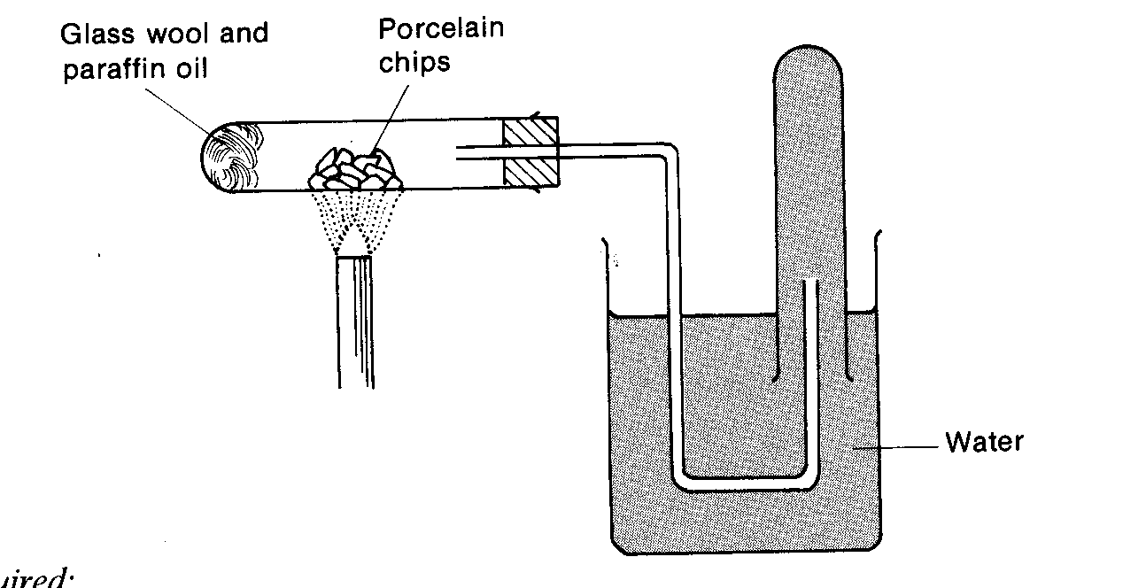
Glass wool and ethanol
Aluminium oxide
C₂H₅OH_{(l)} = C₂H_{4(g)} + H₂O_{(l)}

or
C₂H₅OH_{(l)} - H₂O_{(l)} = C₂H_{4(g)}

- Colourless gas same density as air
- Insoluble in water and polar solvents
- Soluble in non-polar solvents e.g. cyclohexane
- Burns in air to give CO₂ and H₂O and heat [sometimes explosively]
- Unsaturated C = C shown by
- Ethene decolourises bromine water from Red to colourless quickly
- Ethene decolourises acidified manganate (VII) from purple to colourless quickly

1. Why is it desirable to push the glass wool into the tube after the ethanol has been added?
To ensure that all of the ethanol is soaked up.

2. Why should the ethanol not be heated strongly?
Strong heating of the ethanol will cause it to evaporate too quickly
and escape from the tube before it can be dehydrated.

3. Would you expect all the test tubes of gas collected to contain equally pure samples of ethene? Explain your answer.
The first test tubes of gas collected will contain air and ethanol vapour
as well as ethene. Subsequent test tubes of gas collected will contain ethene only.

4. Why is it very important to remove the delivery tube from the water as the Bunsen burner is turned off?
To avoid cold water being sucked back from the trough onto the hot
glass of the reaction tube.

In each of steps 1, 2 and 3 in the investigation of properties, give a reason for the results observed.
Step 1: The limewater is turned milky by the carbon dioxide formed by
the combustion of ethene.
Steps 2 and 3: The decolourisations indicate unsaturation.

No.2 Preparation and Properties of Ethyne

CaC_{2(s)} + 2 H₂O_{(l)} ===> C₂H_{2(g)} + Ca(OH)_{2(s)}
Calcium Dicarbide Ethyne Slaked Lime
- Calcium dicarbide is a grey lumpy solid
- As the reaction proceeds lots of heat is produced [very exothermic] causes fizzing and spattering.
- The solid product, Ca(OH)₂ , is a white powder which occupies more space than the CaC₂
- Ethyne can be purified by passing it through acidified CuSO₄ solution
- To remove impurities such as Hydrogen Sulphide and Phosphine
- Produced by the reaction of the water with traces of Calcium Sulphide [CaS] and Calcium Phosphide [Ca₃P₂] in the CaC₂.
- Ethyne has a sickly sweet smell

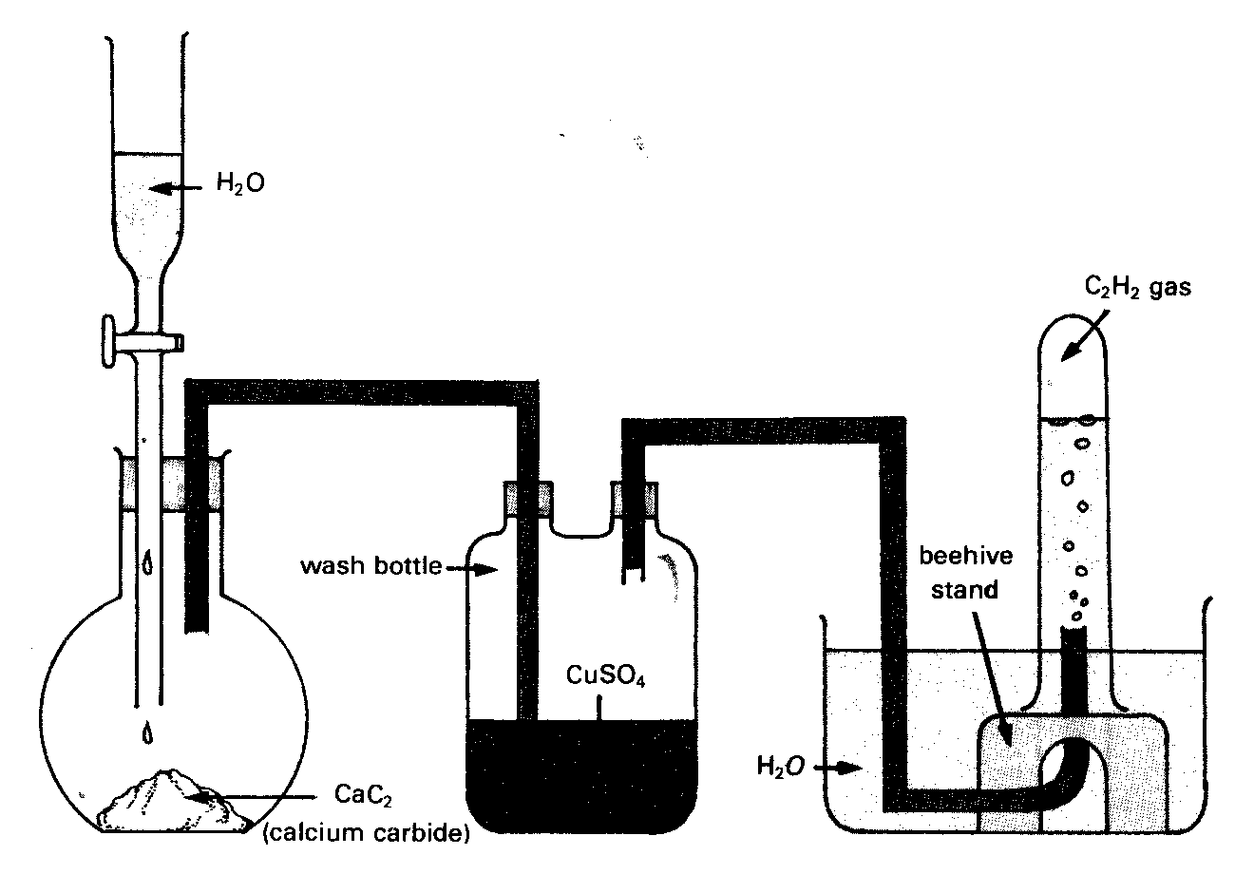

- Burns in air with a very smoky yellow flame. Very hot in excess air - oxyacetylene burner
- Unsaturated C ≡ C
- Decolourises bromine water from Red to colourless – quickly
- Decolourises acidified manganate(VII) from purple to colourless MnO₄⁻ to Mn²⁺ – quickly

Preparation and properties of ethyne

  - Write an equation for the combustion of ethyne, and select a product, which may have caused a colour change in the limewater.

C₂H₂ + 2¹/₂ O₂ → 2CO₂ + H₂O
The carbon dioxide turns limewater milky.

2. Draw the structural formula of a possible product of the reaction in Investigation What does the observed result indicate?
H H H H
\ / | |
C = C or Br – C – C - Br
/ \ | |
Br Br Br Br

1, 2 dibromoethene 1, 1, 2, 2, tetrabromoethane

(Allow products with two hydrogen atoms in the molecule and in which there is one OH group to every Br atom.)

The decolourisation indicates that the ethyne is unsaturated.

  - What does the observed result in Investigation 3 indicate?

This also indicates unsaturation.

  - Why should the first test tube be discarded?

It contains mostly air.

  - In what way do the products of combustion, as described in the equation, differ from what you observed in Investigation 1? Explain.

The smoky, sooty flame indicates that combustion is incomplete due to
insufficient oxygen, and particles of carbon are evident.

Exp 7.6 Extraction of Clove Oil from Cloves
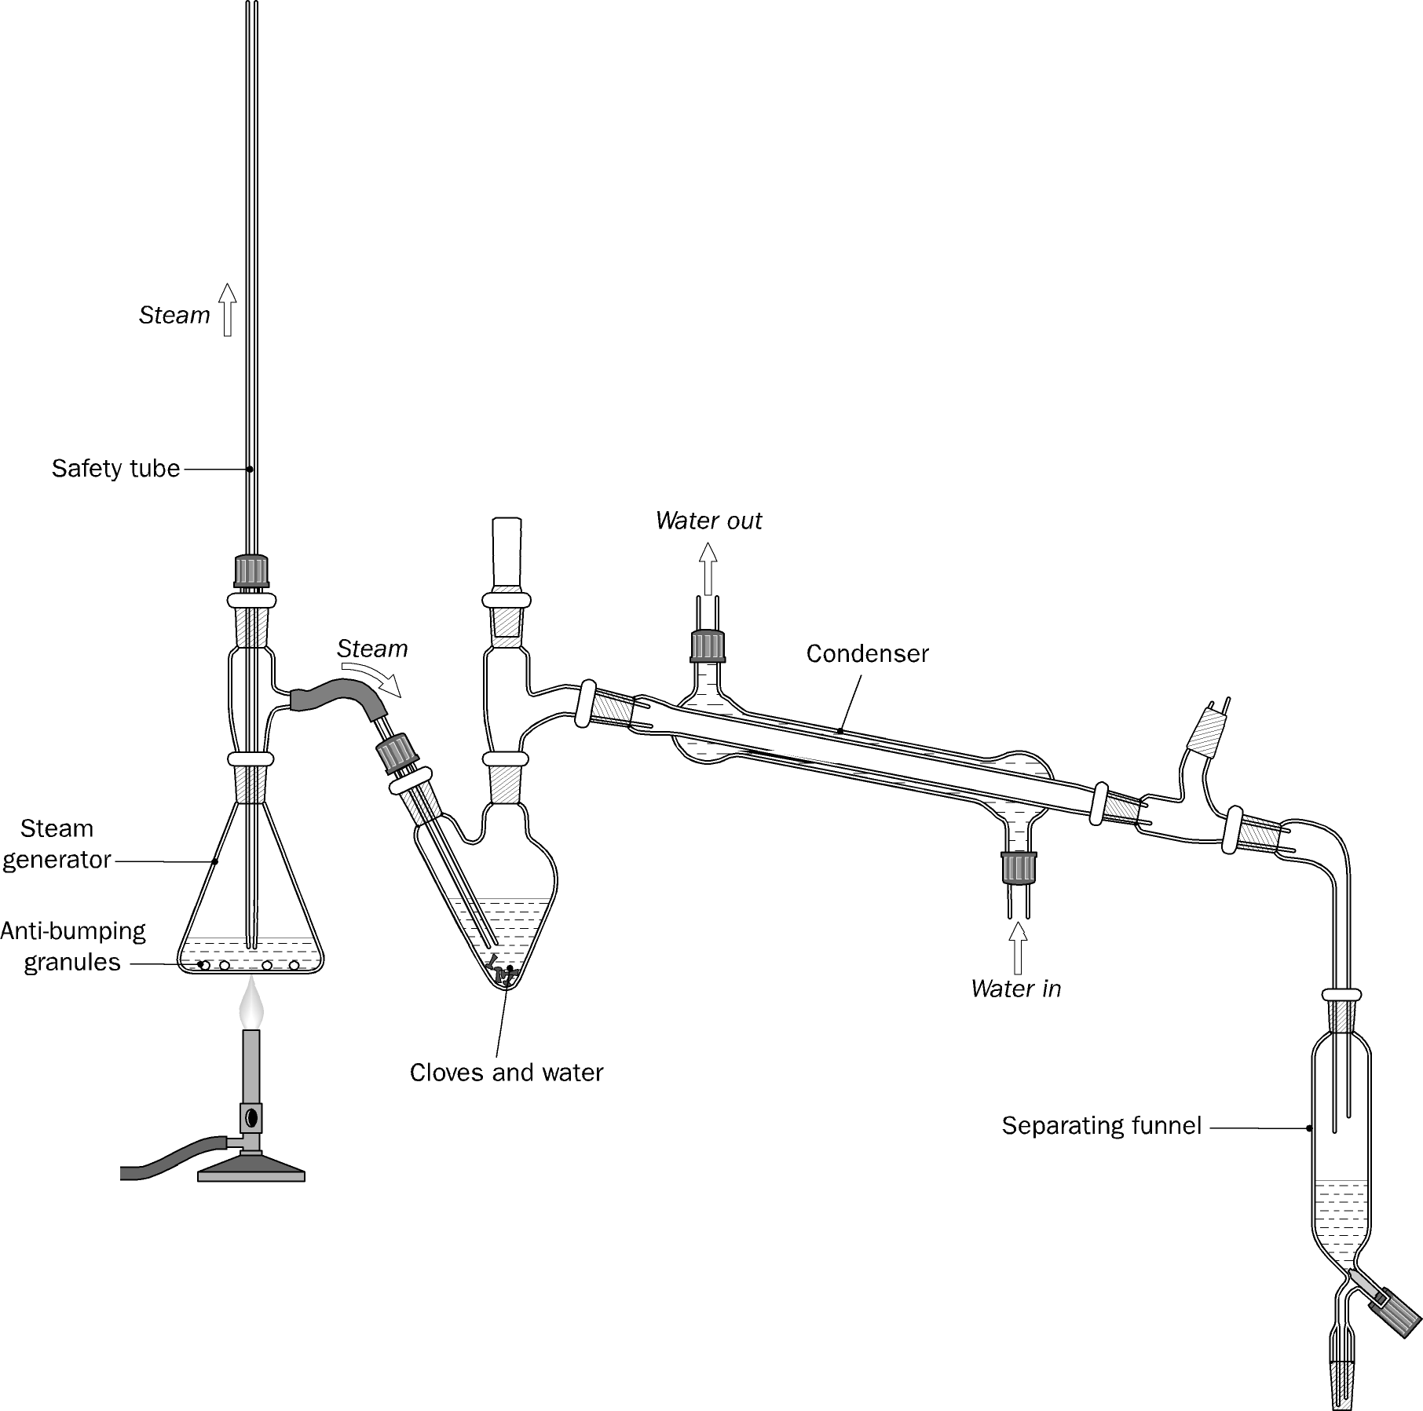
- Make sure you have a safety opening to the atmosphere
- Steam distillation used because some components of clove oil have high BP and this temp would damage molecules in the oil
- Some organic compounds are immiscible with water. Usually these compounds have a low vapour pressure. After mixing them with water, however, the mixture will distil when the sum of the two vapour pressures reaches atmospheric pressure. It follows, then, that this must happen below the boiling point of water.
This process is known as steam distillation.
- Note the mass of the cloves, and place them in the pear-shaped flask. Cover with a little warm water (about 5 cm³).
- Place plenty of water in the steam generator, connect it and boil. Use anti-bumping granules in the steam generator.

- If the level of the boiling water in the steam generator falls too low, the system will not work smoothly. Remove the heat, carefully loosen the safety valve, and top up the steam generator with hot water. Reconnect everything and heat again.
- After 20 to 30 minutes disconnect steam generator to avoid suck-back then turn off the heat.
- Collect 40 - 50 cm³ of the pale milky distillate [emulsion]. Note the smell
- Oil separated by dissolving in solvent, placing in separating funnel
- Collecting organic solvent fraction and then evaporating solvent.

(1) Explain why the clove oil could not be distilled directly from the cloves.

Clove oil contains component molecules whose boiling points are quite high. Heating
them to their boiling point would be destructive.

(2) Explain the principles by which steam distillation works.
Some organic compounds are immiscible with water. Usually these compounds have
a low vapour pressure. After mixing them with water, however, the mixture will distil
when the sum of the two vapour pressures reaches atmospheric pressure. It follows,
then, that this must happen below the boiling point of water. This process is known as
steam distillation.

(3) Suggest a reason why the clove oil is much more soluble in non-polar solvents
(than in water).
The component molecules found in clove oil are often relatively non-polar and will
therefore be more soluble in the non-polar solvent than in water.

No.4 Preparation of Soap

- Reaction is called Saponification or alkaline hydrolysis
- Mix olive oil [or any vegetable oil] with NaOH [ The NaOH is 20% W/V] in ethanol
- Alkaline hydrolysis leads to formation of the sodium salt of the fatty acid
- Boil under reflux to speed up reaction and drive to completion
- Reflux stops volatile components escaping
- Ethanol removed by distillation
- Residue is excess NaOH, glycerol and soap dissolved in minimum hot water
- Cool and pour into concentrated NaCl solution [ called salting out]
- Stir and allow to stand and cool
- Glycerol and NaOH dissolve in brine [concentrated salt solution]
- Soap does not dissolve in brine and forms a cake on top of the liquid
- Waterand glycerol and brine removed by Buchner Filtration [vacuum filtration].
- Soap rinsed with ice-cold water to reduced amount lost by dissolving

Preparation of soap
- How do you explain the cleansing action of soap?

The ionic part of the soap molecule is water-soluble while the non-polar
hydrocarbon part is soluble in oil and grease. Soap therefore allows otherwise
insoluble substances such as oil or grease to become soluble in water.

- Why is a reflux apparatus used in this experiment?

To ensure that the hydrolysis of the fat is as complete as possible. If the mixture
was boiled in an open vessel the ethanol would be lost from the mixture.

- Name the compound CH₂(OH)CH(OH)CH₂(OH).

Propane-1,2,3-triol (Glycerol).

- Draw the structure of a fat from which soap can be made. (you can use C₁₇H_{35...})

C₁₅H₃₁COO ⎯ CH₂
⏐
C₁₅H₃₁COO ⎯ CH
⏐
C₁₅H₃₁COO ⎯ CH₂

- Glycerol is a by-product of the reaction in which soap is made. This does not distil over with the ethanol after the reaction is complete, and remains dissolved in the hot water when added to brine to precipitate the soap. Explain why.

Glycerol (CH₂(OH)CH(OH)CH₂(OH)) has a much higher boiling point than either
ethanol or water. With three hydroxyl groups per molecule, there is considerable
hydrogen bonding between its molecules. There is also considerable hydrogen
bonding between glycerol molecules and water molecules when glycerol is
dissolved in water, and this accounts for glycerol remaining in solution when added to brine.

No.5 Properties of Ethanal

To study the reactions of ethanal with (i) Acidified potassium permanganate (ii) Fehling’s reagent and (iii) Ammoniacal silver nitrate

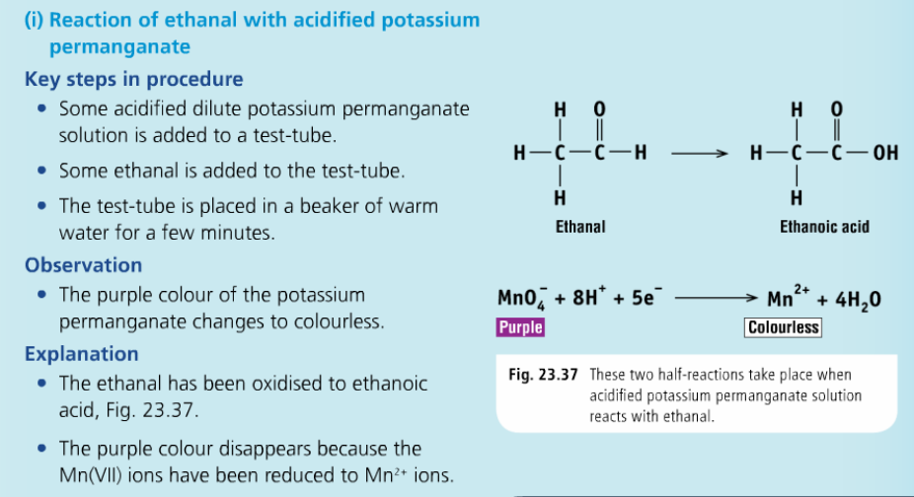
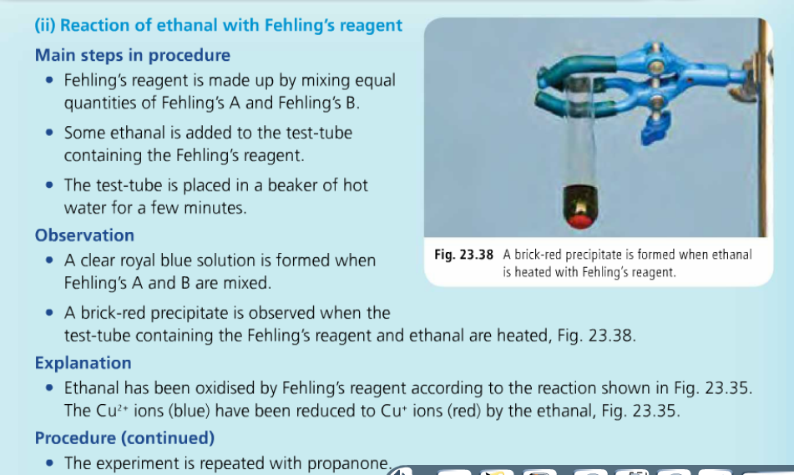
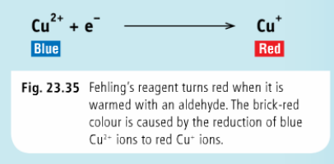
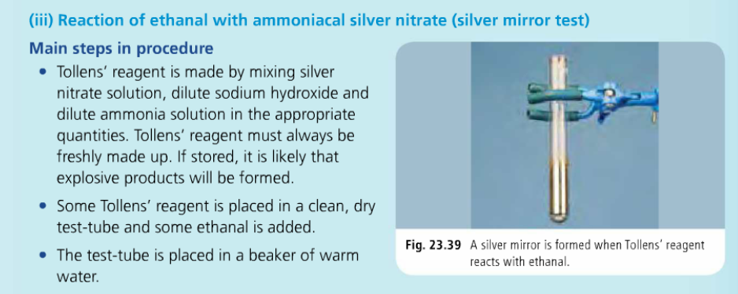
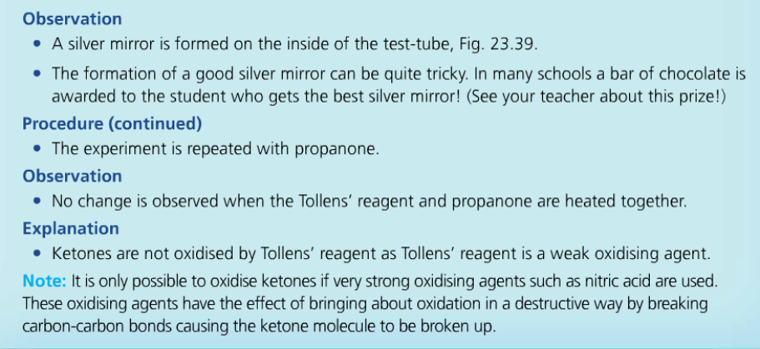
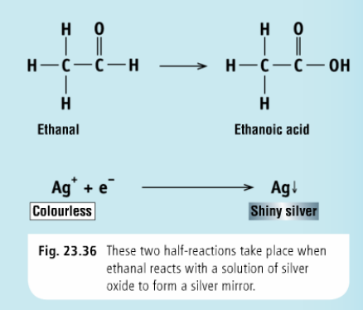
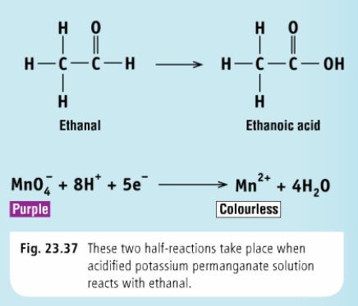

No. 6 Properties of Ethanoic Acid

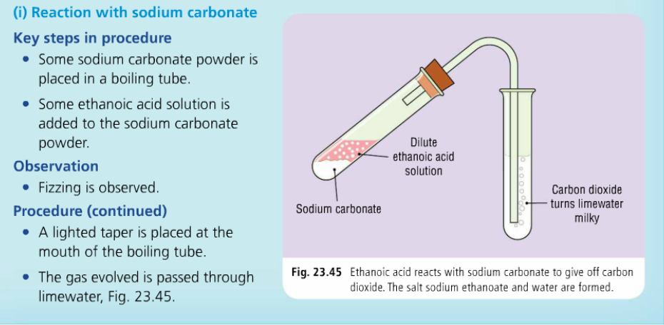
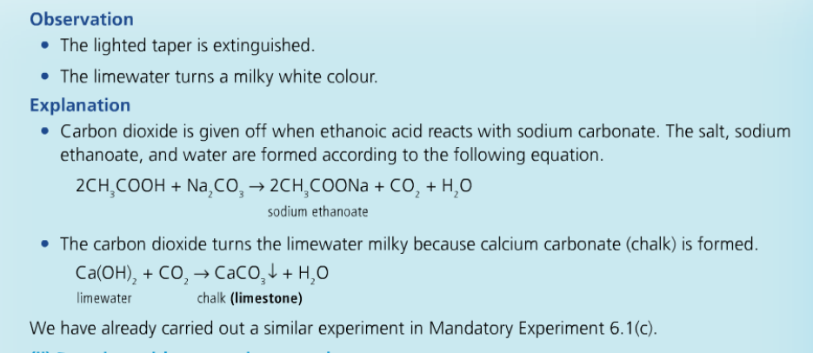
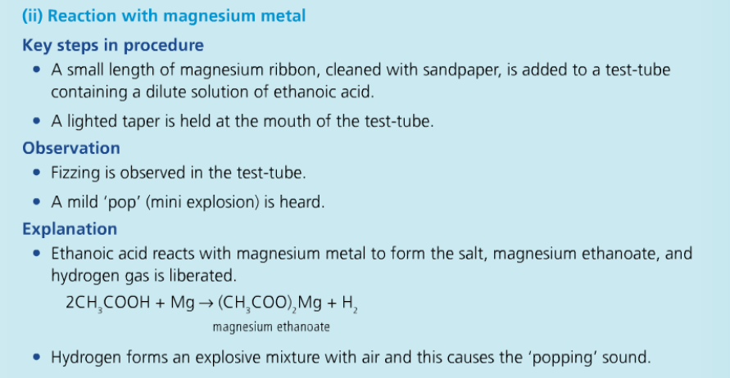
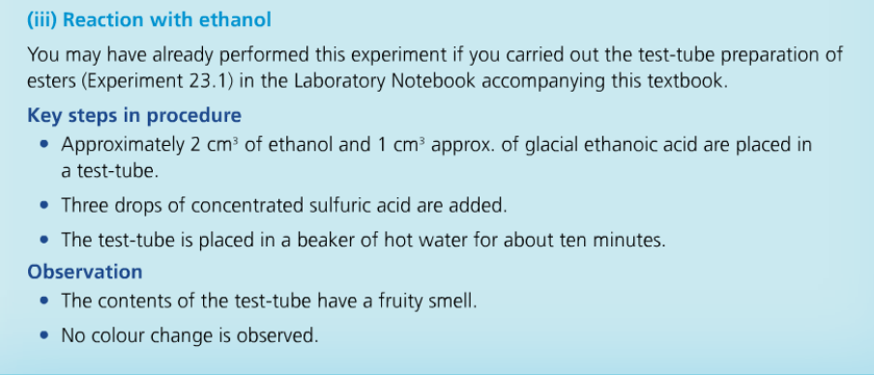
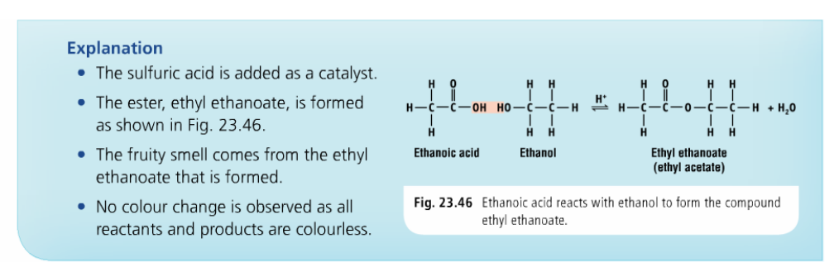

NO.7 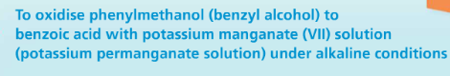

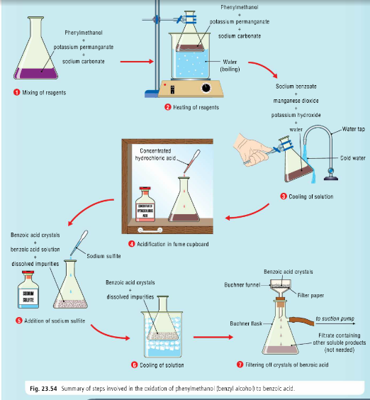

8. Recrystallisation of Benzoic Acid and determination of its melting point

[a] Recrystallising
- Dissolve impure benzoic acid in minimum hot solvent [water]
- Filter using a hot apparatus to remove any insoluble impurities
- Cool to recrystallise
- Filter to retrieve crystals
- Wash crystals with cold solvent [ wash away last traces of impurity with minimum solution of crystals]
- Dry [in desiccator]

[b] Melting point determination
- Take a very small amount
- Heat on aluminium block with thermometer in it
- Melts over several degrees = impure
- Melts sharply = pure

1. Why is it important to use the minimum amount of hot solvent at the crystallisation stage?

It is necessary to use hot solvent in order to produce a solution that will be supersaturated at room temperature. On cooling, the substance recrystallises from solution. The minimum amount of solvent is used because this reduces the quantity of the substance that can remain dissolved when the hot filtered solution is allowed to cool. The yield of recovered crystals would be very low if too much solvent were used.

2. What action could you take if some of the crystals formed on the filter paper or in the leg of the funnel during the hot filtration?

Boiling water would have to be dropped on to the crystals using a dropping pipette to dissolve them. The filtrate would then contain more than the minimum quantity of boiling solvent to keep the substance dissolved. In order to avoid low yields due to the substance remaining dissolved after cooling, it would be necessary to boil off most of the extra solvent before allowing the filtered solution to cool.

3. Suggest a way of obtaining a second crop of crystals from the solution obtained after filtering off the crystals. Would these be as pure as the first crop? How would you confirm this?

Heat the filtered solution to boiling. Allow its volume to reduce by half. Do not boil to dryness. Allow the solution to cool slowly to room temperature and place it in an ice- water bath to cool further. A small second crop of crystals is obtained, and may be filtered off with a Hirsch funnel and dried.
This crop of crystals will not be as pure as the first since the soluble impurities are now more concentrated in the partially evaporated mother liquor and will be incorporated into the crystalline structure of the second batch of crystals more than they were in to the first.

4. What would you expect a forensic scientist to observe about the melting point if two samples of the same substance both equally pure were mixed and the melting point recorded?

Since these samples are chemically identical and of equal purity, there will be no lowering of melting point when they are mixed.

5. What would you expect the scientist to observe about the melting point if pure samples of two different substances with the same melting point were mixed and the melting point recorded?

The two substances when mixed will act as impurities present in one another and so a lowering and broadening of the original melting point will be observed.
This procedure is used to test whether two substances with the same melting point are in fact the same substance or not.

6. Two samples have melting points 115 - l18 ⁰C and 120 – 121 ⁰C. Could they be the same substance? How would you check your answer?

Yes, they could be the same substance. The first one is lower and broader than the second and this difference could be due to impurities. Purify the first sample by recrystallisation and record its melting point again. If it increases and narrows to the same melting range as the second sample they could be the same substance. Carry out a mixed melting point test as referred to in Question 5 to check.

GENERAL EXPERIMENTS

Exp 1.1 Flame tests
- Place sample of salt on clock glass
- Moisten with conc. HCl
- Pick up sample with clean nichrome or platinum wire
- Hold in non-luminous Bunsen flame
- Note colour of flame
  - Sodium Yellow
  - Potassium Lilac
  - Copper Blue-green
  - Lithium Crimson
  - Strontium Red
  - Barium Green
- Line spectra can be seen using a spectroscope

1. Why do metals give off a characteristic colour in a flame?

The energy differences between energy levels in metal atoms vary from metal to metal. Using energy from the flame, electrons in the metal atoms move to higher energy levels, and then return to lower energy levels, emitting light whose energies in each case is equal to the energy difference between the higher energy level and the lower energy level.

2. What procedure is used to avoid cross contamination?

If platinum wire is used, either a separate platinum wire is used for each test, or the wire is thoroughly cleaned with concentrated hydrochloric acid after each test.
If wooden splints are used, a separate splint is used for each test.

Exp 1.2 Redox Reactions of Group VII and Displacement Reactions of Metals

Redox reactions
- Make solutions of
  - sodium sulphite
  - Iron(II) sulphate
  - Sodium Bromide
  - Potassium Iodide
- Make chlorine solution
- Pour it into each solution, shake and note what happens
  - Sulphite is oxidised to sulphate [use test from Exp. 2.1]
  - Green iron(II) is oxidised to brown iron(III)
  - Colourless bromide solution is oxidised as Red bromine forms
  - Colourless iodide solution is oxidised as brown iodine forms
Displacement reactions
- Place copper sulphate solution in 2 test tubes
- Add Zn to one and Mg to another
- Blue colour of Cu²⁺ disappears as Cu is displaced by Zn
- Blue colour of Cu²⁺ disappears as Cu is displaced by Mg
- More active metal displaces less active metal from solution
- Zn_{(s)} + Cu²⁺ _{(aq)} = CU_{(s)} + Zn²⁺_{(aq)}

(a) Redox reactions of the halogens
(b) Displacement reactions of metals

- Write out a full list of equations for all the redox reactions that took place during this experiment. Using oxidation numbers, label the species that have been oxidised and reduced, e.g.
Cl₂ + 2Br⁻_{(aq)} → 2Cl⁻_{(aq)} + Br₂
0 -1 -1 0
r o

The following are the equations to be labelled by the student:

Cl₂ + 2Br⁻_{(aq)} → 2Cl⁻_{(aq)} + Br₂
0 -1 -1 0
r o

Cl₂ + 2I⁻_{(aq)} → 2Cl⁻_{(aq)} + I₂
0 -1 -1 0
r o

- The iodine/thiosulfate titration to be dealt with in experiment 4.7 is another redox reaction involving a halogen. The equation for the reaction is
2Na₂S₂O₃ + I₂ → 2NaI + Na₂S₄O₆
Show that the iodine is acting as an oxidising agent there as well.

2Na₂S₂O₃ + I₂ → 2NaI + Na₂S₄O₆
+1 +2–2 0 +1-1 +1+(2.5)-2
o r
The iodine is reduced, and is therefore an oxidising agent.

- Describe the tests you would use to distinguish between sulfite and sulfate anions in aqueous solution.

Add 2 cm³ of the solution to be tested to a clean test tube. Using a dropping pipette add
a few drops of barium chloride solution. A white precipitate forms.
Now add 2 cm³ of dilute hydrochloric acid. The white precipitate
will dissolve if a sulfite is present, and will not dissolve if a sulfate is present.

- Explain why it is difficult to make an aqueous solution of iodine. What particular method is used to overcome this problem?

Iodine crystals dissolve very poorly in water, because iodine is non-polar.
Iodine dissolves readily in an aqueous solution of potassium iodide,
because it reacts to form I₃⁻ ions. A solution of I₃⁻ ions is always treated as
an aqueous solution of iodine, as I₃⁻ ions release I₂ molecules in reactions.

- An aqueous solution of chlorine is often made by reacting concentrated hydrochloric acid with a diluted commercial bleach solution. The active ingredient in commercial bleach is sodium hypochlorite (NaOCl). The equation for the reaction is
NaOCl + 2HCl → Cl₂ + NaCl + H₂O
Show what species are oxidised and reduced during this reaction.

NaOCl + 2HCl → Cl₂ + NaCl + H₂O
+1-2+1 +1-1 0 +1 -1 +1-2
r o

- The position of zinc in the Periodic Table would allow you to predict the colour of its sulfate salt solution. Explain.

Zinc is a d-block metal but it is not a transition metal. It therefore will not
be expected to form coloured compounds.

- Explain why magnesium is more reactive than zinc.

Magnesium atom has a larger atomic radius and a smaller nuclear charge than a zinc atom. Because of this, and despite the fact that there is extra screening of outer electrons by electrons in inner energy levels in a zinc atom compared to a magnesium atom, the outer electrons in a magnesium atom are not as tightly bound as those in an atom of zinc. Magnesium is therefore higher on the electrochemical series and more reactive than zinc.

- What would you expect to see happen if a piece of copper wire was suspended in a solution of silver nitrate? (Silver nitrate is very expensive but your teacher may be able to demonstrate this experiment.)

Crystals of silver should appear on the surface of the copper wire. The
solution should gradually take on a blue colour (Cu⁺²_{(aq)}).

- Carry out some research to find out why commercial photography laboratories might have a special interest in these kinds of reactions.

Silver halides are reduced to silver when photographic film or paper is
exposed to light. More silver halide is reduced when the film or paper is
being developed. Unreacted silver halide is dissolved away near the end of
the processing. The silver should be recovered as it is a valuable metal and
would damage the environment as a waste chemical. One possible way is
to reduce the metal halide by reaction with a metal higher up on the
electrochemical series.

Exp 2.1 Identifying Anions

Anions: Negatively charged ions.
Attracted to opposite charge of the anode in electrolysis.

Chloride Cl⁻
- Place in test tube and dissolve
- Add acidified silver nitrate solution
- White precipitate forms
- Add Ammonia solution
- White Precipitate re-dissolves

Nitrate NO₃¹⁻: [Brown Ring Test]:
- Place in a test tube and dissolve
- Add Iron (II) sulphate solution and mix
- Pour in Concentrated sulphuric acid (Hold test tube at 45 degrees)
- Acid sinks to bottom and brown ring forms between the layers

Sulphite: SO₃²⁻
- Place in a test tube and dissolve
- Add Barium Chloride solution
- White precipitate of Barium Sulphite should form
- Add some dilute HCl
- White precipitate should re-dissolve [compare to sulphate]

Sulphate SO₄²⁻
- Place in a test tube and dissolve
- Add some Barium Chloride solution
- White precipitate of Barium Sulphate forms
- Does not re-dissolve in dilute HCl [compare to sulphite]

Carbonate: CO₃²⁻
- Place sample in test tube and add dilute HCl
- If a gas is produced test with lime water - if CO₂ then lime water goes milky
- Substance is either a carbonate or hydrogencarbonate.
- Add magnesium sulphate to solution
- White precipitate then carbonate if not it is a hydrogencarbonate

Hydrogencarbonate HCO₃²⁻
- Place sample in test tube and add dilute HCl
- If a gas is produced test with lime water - if CO₂ then lime water goes milky
- Substance is either a carbonate or hydrogencarbonate.
- Add magnesium sulphate solution
- If no white precipitate then it is a hydrogencarbonate

Phosphate PO₄³⁻
- Place in a test tube and dissolve
- Add a few drops of Ammonium molybdate solution
- Add a few drops of concentrated HNO₃
- A yellow precipitate forms [may need to be heated in water bath]

1. Describe the appearance of pure samples of each of the following salts: sodium carbonate, sodium hydrogencarbonate, sodium sulfate, sodium sulfite, sodium chloride, sodium nitrate, disodium hydrogen phosphate.
They are all white crystalline solids. The samples used in the experiment are aqueous solutions of the salts.

2. Explain the steps you would take to identify which of these anions are present in a mixture of salts.
(i) Take a 2 cm³ sample of the mixture. Add dilute hydrochloric acid solution and collect any gas evolved and test with limewater. If carbon dioxide gas was evolved then either a carbonate or a hydrogencarbonate or both anions are present.
Take another 2 cm³ sample of the mixture. Add MgSO₄ solution. If a precipitate forms, carbonate anion is present. Filter off the precipitate and heat. If further precipitate appears after heating, hydrogencarbonate ion is also present.
(ii) Take another 2 cm³ sample of the mixture. Test with AgNO₃ solution. If chloride ion is present a white precipitate is formed. This precipitate dissolves in dilute ammonia solution.
(iii) Take another 2 cm³ sample of the mixture. Test with FeSO₄ solution and concentrated sulfuric acid. A brown ring is observed if nitrate ion is present.
(iv) Take another 2 cm³ sample of the mixture. Test with ammonium molybdate reagent. If phosphate ion is present a yellow precipitate is formed. This precipitate dissolves in dilute ammonia solution.
(v) Take another 2 cm³ sample of the mixture. If there is no phosphate ion present, add BaCl₂ solution and a precipitate will appear if either sulfite or sulfate is present. Add dilute hydrochloric acid dropwise. If all the precipitate dissolves only the sulfite anion was present. If there is a mixture of sulfite and sulfate anions some of the precipitate will remain but some will dissolve producing sulfur dioxide gas, which has a distinctive smell.

3. Which of these anions might be expected to be found in treated tap water?
Give a possible source of each anion you mention.
Hydrogencarbonate anion from water hardness.
Sulfate ion from flocculating agents or water hardness.
Chloride ion from water hardness or sterilisation treatment.

4. How would you distinguish two unlabelled samples, one of which is a carbonate and the other which is a hydrogencarbonate, from each other?
Take a 2 cm³ sample of each sample. Add MgSO₄ solution. If a precipitate forms, it confirms the carbonate anion is present. Heat the other test tube and a precipitate appears upon heating a sample with the hydrogencarbonate ion.
5. How would you distinguish two unlabelled samples, one of which is a sulfate and the other which is a sulfite, from each other?

Exp. 3.1 To Measure the Relative Molecular Mass of a Volatile Liquid

- Find mass of dry conical flask, rubber band and aluminium foil
- Pour 10cm³ of volatile liquid [chloroform] into conical flask
- Seal top with foil and rubber band – put small hole in foil
- Place flask in a large beaker of boiling water
- Leave flask till all liquid has evaporated at 100⁰C
- Remove flask and allow to cool - the vapour condenses back to liquid
- Dry outside of flask and foil
- Reweigh the flask, foil and band
- Calculate mass of the liquid whose vapour filled flask [ change in mass]
- Find volume of flask by filling with water and pouring into graduated cylinder
- Record atmospheric pressure using barometer.
- Calculate the volume of the vapour at S.T.P using: V₁ = P₂V₂T₁/ P₁T₂
- V₂ = volume of vapour at S.T.P.
- Know the mass of volume V₂
- Find the mass of 1cm³ [mass / V₂]
- Multiply by 22,400 to get the mass of 22,400cm³ of vapour = RMM

1. Why is it necessary that the liquid used in this experiment is volatile?

The liquid must be capable of forming a vapour at the temperature of the experiment so that the ideal gas equation can be applied. The equation applies with greatest accuracy to those vapours that are most like ideal gases. Gases are least ideal when on the point of condensing, so the greater the difference between the boiling point of the liquid and the temperature of the reaction the more accurate the results will be.

2. Name another technique for measuring relative molecular mass.

Mass spectrometry

3. Since the vapour is not an ideal gas, which quantity measured in the experiment is most likely to introduce inaccuracy in the result and why?

The temperature and pressure of the surroundings were measured. These measurements are independent of whether the gas is ideal or not. The gas constant is given. The measurement of volume is the measurement that would be expected to be least accurate when used in the ideal gas equation, when compared to the volume that would be obtained if an ideal gas could be used. A real gas occupies a smaller volume than an ideal gas because of intermolecular attractions in real gases, e.g. hydrogen bonding, van der Waals’ forces etc.

4. If a small drop of water were present in the flask used in Method 1 or the gas syringe used in Method 2, how would this affect the results?

The small drop of water would vaporise during the experiment and occupy quite a large volume. The reading for the volume of the volatile liquid's vapour would be far too large and the result calculated for M_{r} very inaccurate as a result. It would be too small.

Exp 5.1 Determine the heat of reaction on of hydrochloric acid with sodium hydroxide

- 100 ml 0.1 M HCl
- 100 ml 0.1 M NaOH
- take temperature of both and average = starting temp
- mix in polystyrene cup [insulator so no heat escapes]
- Record highest temp
- Calculate change in temp
- H = mcΘ
- Mass = 0.2 kg
- C = 2.4 kJ kg⁻¹
- Θ = temp change
- Heat change for 0.1 mole therefore multiply by 10 for 1 mole

1.What precautions are used in this experiment to minimise heat loss to the surroundings?
A polystyrene cup is used because the specific heat capacity of polystyrene is
negligible. The use of a lid on the cup further reduces heat loss.

2.Chemistry data books give the heat of reaction of one mole of hydrochloric acid with one mole of sodium hydroxide as -57 kJ per mole. Why do you think your answer is different from this?
The values obtained by the students may not be -57 kJ per mole because (i)
graduated cylinders (which are not very accurate) are used to measure the
volumes of acid and base respectively, (ii) the concentrations of the solutions used
are not known to a high degree of accuracy, and (iii) a number of assumptions
made in carrying out the experiment may introduce errors. These assumptions are
(a) the specific heat capacity of the polystyrene calorimeter is zero, (b) there is no
loss of heat to the surroundings, (c) the specific heat capacity of the final solution
is the same as that of water and (d) the densities of the acid and base are equal to
the density of water.

3. If 1 M nitric acid solution is used instead of 1 M hydrochloric acid solution in this experiment, or if 1 M potassium hydroxide solution is used instead of 1 M sodium hydroxide solution, similar values are obtained for the heat of reaction. Explain why this happens.
Hydrochloric acid and nitric acid are both strong monobasic acids, and are fully
dissociated in water. Potassium hydroxide and sodium hydroxide are both strong
monoprotic bases, and are also fully dissociated in water. In all the experiments
referred to, the only reaction that occurs is that between the hydrogen ions
formed when the acid dissociates in water and the hydroxide ions formed when
the base dissociates in water:
H⁺ + OH⁻ → H₂O
Consequently, the heat of reaction is the same.

Exp 6.2 To determine the effect of concentration and temperature on the rate of reaction.

1: Concentration
- Using sodium thiosulphate and dilute HCl
- Make up different % solutions (100%, 80%, etc.) in conical flask
- Pipette 50 ml thiosulphate into conical flask
- Place flask on paper marked with cross
- Add 10 ml dilute HCl
- Record time in seconds it takes for cross to disappear
- Repeat for each concentration
- Draw graph: rate of reaction [ 1000/s] against concentration
- Rate of reaction directly proportional to concentrations of reactants
- Doubling concentration of one reactant doubles the rate of reaction

2: Temperature.
- Pipette 50 ml thiosulphate into conical flask \Using sodium thiosulphate add dilute HCl
- Place conical flask in water bath at different temperatures and Heat to required temperature
- Place the flask on paper marked with cross
- Add 10 ml dilute HCl
- Record time in seconds it takes for cross to disappear
- Repeat for each temperature
- Draw graph: rate of reaction [ 1000/s] against temperature
- 10°C rise doubles rate of reaction
- What is the effect of increasing the concentration on the reaction time?

The reaction time is decreased.

- What is the effect of increasing the concentration on the reaction rate?

The rate is increased.

- What is meant by saying that two quantities are directly proportional?

If one of the quantities is increased/decreased by a certain factor, the other
changes in exactly the same way.

- What is the effect of raising the temperature on the reaction time?

The reaction time is decreased.

- What is the effect of raising the temperature on the reaction rate? Suggest two factors responsible for the result observed.
The rate is increased. The higher temperature results in greater kinetic energy of the particles present. This causes:
  - more collisions per unit time, and
  - a greater proportion of the collisions to have the activation energy needed for products to form.
Both (i) and (ii) result in a rate increase.

- Suggest a reason why it is not recommended to carry out the experiment at temperatures higher than about 60 ⁰C.

The reaction occurs so quickly that it is not possible to measure the time
accurately.

- Which is the limiting reactant in the temperature experiment?

100 cm³ of 0.05 M Na₂S₂O₃ contains:

100/1000 x 0.05 = 0.005 moles Na₂S₂O₃

5 cm³ of 3 M HCl contains:
5/1000 x 3 = 0.015 moles HCl

According to the balanced equation, the reacting ratio is Na₂S₂O₃ : HCl = 1:2
The amounts used are in the ratio
Na₂S₂O₃ : HCl = 0.005: 0.015 = 1 : 3

Clearly Na₂S₂O₃ is the limiting reactant.

Exp 6.1 To monitor the rate of production of oxygen from hydrogen peroxide
using manganese dioxide as a catalyst
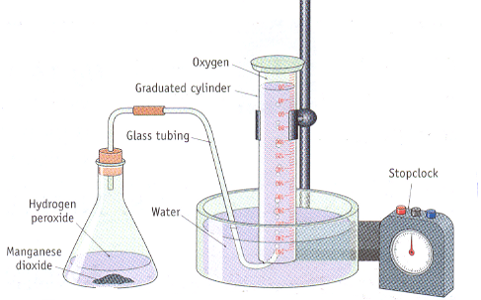
- Place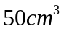of hydrogen peroxide solution in conical flask
- Hold flask horizontal
- Add small amount of manganese dioxide to neck of conical flask, insert rubber stopper
- Turn flask to normal position and MnO₂ will fall in and the reaction will start.
- At 30 second intervals record volume of gas in cylinder till reaction over
- Plot a graph of volume of oxygen against time
- H₂O₂ = H₂O + ½ O₂
- Average rate of evolution of oxygen = Total volume given off
Time
- Instantaneous rate = rise/ run of tangent drawn at any point on graph

- Why is the slope of the graph steepest in the early stages of the reaction?

Since rate is proportional to concentration, the greatest rate, indicated by the
steepest slope, is evident in the early stages when the concentration of hydrogen
peroxide is at a maximum.

- At what stage is the reaction complete?

When the graph becomes horizontal.

- What would be the effect on the graph of doubling the amount of
manganese(IV) oxide?

The increased surface area of catalyst would speed up the reaction, giving a
steeper slope and an earlier completion. The volume of oxygen produced would
be unchanged.

- Would doubling the manganese(IV) oxide create a practical difficulty? Explain
your answer.

Yes. The production of oxygen could become too quick for accurate monitoring.

- What would be the effect on the graph of doubling the concentration of
hydrogen peroxide?

Increasing the concentration of a reactant would speed up the rate, as indicated
by a steeper slope. Doubling the concentration would produce double the final
volume of oxygen.

- Would doubling the concentration of hydrogen peroxide create a practical
difficulty? Explain your answer.

Yes. The capacity of the collection vessel could be exceeded.

Exp 7.7 Separation of a mixture of indicators using Paper Chromatography

- Set up chromatography tank
- Place 1 cm depth of Solvent in tank
- Draw line 3 cm from bottom of paper and one near top
- Spot line with individual indictors and the mixture of indicators several times allowing to dry between applications
- Place end of chromatogram in solvent making sure spots are above solvent
- Cover tank and allow to run till solvent front reaches line near top
- Remove and dry
- Calculate and record Rf values [distance moved by substance / distance moved by solvent front] of each substance

Q.1 Why is a paper chromatography tank not used for a considerable time after the chromatography solvent has been added?
To allow time for the tank to become saturated with solvent vapour.

Q.2 Why are two lines usually drawn on a paper chromatogram?
One line is needed to indicate where the samples start from, and the other to indicate the distance travelled by the solvent front, which enables the R_{f} values to be calculated.

Q.3 When is it possible to separate two components of a mixture using paper chromatography?
When one of the components is attracted to a significantly different extent by the stationary phase and/or the mobile phase.

Q.4 When two substances are found to have different R_{f} values in an experiment carried out under the same conditions, what does this mean?
The two substances are not identical.

(b) Separation of a mixture of indicators using thin layer
chromatography

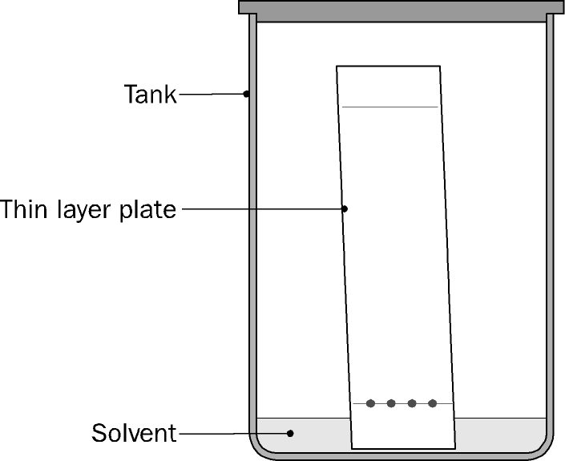

- Cut a piece of filter paper to fit around the walls of the tank.

- Add enough industrial methylated spirits to the tank to allow it to saturate the filter paper and give a depth of about 10mm at the bottom.

- Cover the tank, and allow to stand for 10 minutes.

- Draw a line lightly with a pencil on a thin layer plate a little more than 10 mm from the bottom of the plate. Draw a horizontal line near the top of the plate.

- Using a capillary tube, place a small spot of each sample on the line near the bottom of the plate. Allow to dry – a hair drier may be used to speed up drying.

- Stand the plate carefully in the tank, ensuring that the samples are above the surface of the liquid. Cover the tank, and allow the solvent front to rise up the plate to the line near the top. Remove the plate, and allow to dry.

Q.1 Why is filter paper placed around the walls of a thin layer chromatography tank?
To speed up saturation of the tank with solvent vapour.

Q.2 Why are two lines usually drawn on a thin layer chromatogram?
One line is needed to indicate where the samples start from, and the other to indicate the distance travelled by the solvent front, which enables the R_{f} values to be calculated.

Q.3 When is it possible to separate components of a mixture using thin layer chromatography?
When one of the components is attracted to a significantly different extent by the stationary phase and/or the mobile phase.

(c) Separation of a mixture of indicators using column
chromatography

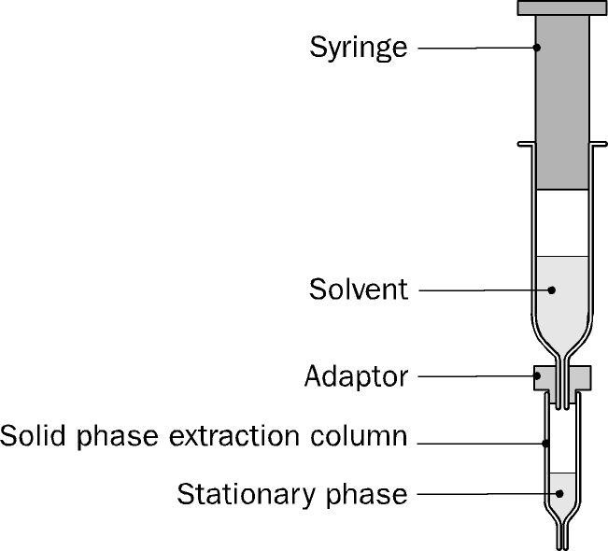
- Flush the solid phase extraction column through with methanol, using the plunger.
- Flush the solid phase extraction column through with water a number of times.
- Place a sample of the mixture of indicators on the top of the column – the sample should cover the top of the column to a depth of slightly less than half the length of the column solid phase.
- Half fill the syringe with air and, using the adaptor, attach the syringe to the column. Using the plunger, gently force the mixture into the column.
- Have several small test tubes available to collect the different components of the mixture.
- Add about 4 cm³ of 35% methanol solution to the syringe, and using the adaptor, attach the syringe to the column.
- Using the plunger force the mixture through the column.
- Collect the different components of the mixture in separate test tubes.
- Describe the colour of each of the components.

- When is it possible to separate components of a mixture using column chromatography?
When one of the components is attracted to a significantly different extent by the stationary phase and/or the mobile phase.

- What is the purpose of the syringe when components of a mixture are being separated using a solid phase extraction column?
To allow the solvent to be forced through the column under pressure, thereby achieving a rapid separation.

- Why is an adaptor necessary?
To enable the syringe to be fitted exactly into the column – without this, it is not possible to force the liquid through the column under pressure.

- Why is it necessary to flush a solid phase extraction column with methanol and then with water before using it to carry out a separation?

Methanol will remove any residual organic material from the column. Water will then remove any remaining methanol.

Exp 8.1 Illustrations of Le Chatelier’s Principle

[a] equilibrium between CoCl₄²⁻ and Co(H₂O) ₆⁺ CoCl₄²⁻ + 6 H₂O = Co(H₂O) ₆⁺ + 4 Cl⁻
Blue Pink
  - Effect of Concentration
  - dissolve 4 g of cobalt chloride – 6 water in 40 cm³ deionised water
  - pink solution formed
  - add Conc. HCl in fume cupboard till blue colour forms [gets Cl⁻ down by going left]
  - add water pink colour returns [ gets water down by going right]
  - repeat several times

  - Effect of temperature
  - place test tube in water at 90ºC – goes blue – system tries to lower temp by going to left endothermic
  - place test tube in crushed ice – goes pink – system tries to raise temp by going to right exothermic
[b] Equilibrium between Cr₂O₇²⁻ and CrO₄²⁻ Cr₂O₇²⁻ + H₂O = CrO₄²⁻ + 2 H⁺
orange yellow
  - Effect of Concentration
  - place Na₂Cr₂O₇ soln. in test tube – orange
  - add some dil. NaOH - goes yellow - uses up H⁺ system replaces by making H⁺ and chromate [CrO₄²⁻]
  - Add dil. H₂SO₄ goes orange add H⁺ system uses it up by making dichromate [Cr₂O₇²⁻]

[c] Equilibrium between Fe³⁺ and Fe(CNS)² Fe³⁺ + CNS⁻ = Fe(CNS)²⁺
yellow red
  - Mix 5 ml of iron(III) chloride and Potassium thiocyanate in beaker – red because the equilibrium is to right
  - Add conc. HCl – red colour disappears – Cl⁻ reacts with Fe³⁺ and removes it
  - Fe(CNS)²⁺ used up as Fe³⁺ is replaced – red colour goes

(a) The equilibrium between CoCl₄²⁻ and Co(H₂O)₆²⁺
- Why is a control used in this experiment?

In order to be able to compare colours formed with the original colour.

- Explain why there is a colour change in the mixture when a boiling tube containing it is placed in ice.

In the equilibrium
CoCl₄²⁻ + 6H₂O Co(H₂O)₆²⁺ + 4Cl⁻
Blue Pink
the forward reaction is exothermic. Lowering the temperature favours the
exothermic reaction, according to Le Chatelier’s Principle, and so the
colour changes to pink.

- Explain why there is a colour change in the mixture when a boiling tube containing it is placed in hot water.

In the equilibrium
CoCl₄²⁻ + 6H₂O Co(H₂O)₆²⁺ + 4Cl⁻
Blue Pink
the reverse reaction is endothermic. Raising the temperature favours the
endothermic reaction, according to Le Chatelier’s Principle, and so the
colour changes to blue.

- Explain why there is a colour change in the mixture when water is added.

Adding water shifts the equilibrium to the right, according to Le Chatelier’s
Principle, and so the colour changes to pink.

- Explain why there is a colour change in the mixture when concentrated hydrochloric acid is added.

Adding hydrochloric acid shifts the equilibrium to the left, according to Le
Chatelier’s Principle, and so the colour changes to blue.

- How can it be shown that it is the chloride ions in the hydrochloric acid that cause this colour change?

Add solid sodium chloride to the “in-between” solution – a colour change to blue occurs. Since chloride ions are the only type of ion found in both hydrochloric acid and sodium chloride, the effect must be due to the chloride ions.

(b) The equilibrium between CrO₄²⁻ and Cr₂O₇²
- When sodium hydroxide solution is added to a solution of potassium
dichromate, a colour change occurs. Describe the colour change, and explain
why it happens.

The colour changes from orange to yellow. In the equilibrium

Cr₂O₇²⁻ + H₂O 2CrO₄²⁻ + 2H⁺
orange yellow
adding sodium hydroxide solution removes H⁺, and so shifts the equilibrium
to the right, according to Le Chatelier’s Principle. Therefore the colour
changes to yellow.

- Why does adding hydrochloric acid reverse the colour change referred to in question 1?

The colour changes from yellow to orange. In the equilibrium
Cr₂O₇²⁻ + H₂O 2CrO₄²⁻ + 2H⁺
orange yellow
adding acid increases the concentration of H+ ions and therefore shifts the
equilibrium to the left, according to Le Chatelier’s Principle. Therefore the
colour changes to orange.

- Why is a control used in this experiment?

In order to be able to compare colours formed with the original colour.

- Describe and explain what happens when hydrochloric acid is added to a solution of potassium chromate.

The colour changes from yellow to orange. In the equilibrium

Cr₂O₇²⁻ + H₂O 2CrO₄²⁻ + 2H⁺
orange yellow
adding acid increases the concentration of H⁺ ions and therefore shifts the
equilibrium to the left, according to Le Chatelier’s Principle. Therefore the
colour changes to orange.

(c) The equilibrium between Fe³⁺ and Fe(CNS)²⁺
- Why is a control used in this experiment?

In order to be able to compare colours formed with the original colour.

- When potassium thiocyanate solution is added to a solution of iron(III) chloride, a colour change occurs. Describe the colour change, and explain why it happens.

The colour changes from yellow to red. In the equilibrium
Fe³⁺ + CNS⁻ Fe(CNS)²⁺
yellow red
some of the red complex Fe(CNS)²⁺ is formed, giving rise to the red colour.

- Why does adding hydrochloric acid reverse the colour change referred to in question 2?

In the equilibrium
Fe³⁺ + CNS⁻ Fe(CNS)²⁺
yellow red
adding hydrochloric acid causes the removal of Fe³⁺, due to the formation of a
complex ion containing iron and chlorine. This results in a shift of the
equilibrium to the left, according to Le Chatelier’s Principle, and so the colour
changes to yellow.

- How can it be shown that it is the chloride ions in the hydrochloric acid that
cause this reversal?

Add saturated potassium chloride solution (or saturated sodium chloride
solution) to the red solution – a colour change to yellow occurs. Again, this is
due to the removal of Fe³⁺ because of the formation of a complex ion
containing iron and chlorine. Since chloride ions are the only type of ion
found in both hydrochloric acid and sodium chloride, the effect must be due to
the chloride ions.

- Why is water added in step 4 of the procedure?

To show by comparison that the extent of lightening of the colour is not due to a diluting effect.

- Name a substance other than hydrochloric acid that can reverse the colour change referred to in question 2.

Potassium chloride, or sodium chloride.
- Why is a control used in this experiment?

In order to be able to compare colours formed with the original colour.

- When potassium thiocyanate solution is added to a solution of iron(III) chloride, a colour change occurs. Describe the colour change, and explain why it happens.

The colour changes from yellow to red. In the equilibrium
Fe³⁺ + CNS⁻ Fe(CNS)²⁺
yellow red
some of the red complex Fe(CNS)²⁺ is formed, giving rise to the red colour.

- Why does adding hydrochloric acid reverse the colour change referred to in question 2?

In the equilibrium
Fe³⁺ + CNS⁻ Fe(CNS)²⁺
yellow red
adding hydrochloric acid causes the removal of Fe³⁺, due to the formation of a
complex ion containing iron and chlorine. This results in a shift of the
equilibrium to the left, according to Le Chatelier’s Principle, and so the colour
changes to yellow.

- How can it be shown that it is the chloride ions in the hydrochloric acid that
cause this reversal?

Add saturated potassium chloride solution (or saturated sodium chloride
solution) to the red solution – a colour change to yellow occurs. Again, this is
due to the removal of Fe³⁺ because of the formation of a complex ion
containing iron and chlorine. Since chloride ions are the only type of ion
found in both hydrochloric acid and sodium chloride, the effect must be due to
the chloride ions.

- Why is water added in step 4 of the procedure?

To show by comparison that the extent of lightening of the colour is not due to a diluting effect.

- Name a substance other than hydrochloric acid that can reverse the colour change referred to in question 2.

Potassium chloride, or sodium chloride.

Exp 9.1 To Estimate the Concentration of Free Chlorine in Swimming Pool Water or Bleach.
(Using a colorimeter)

- HOCl called free chlorine put in as calcium hypochlorite [Ca(OCl)₂]
- pH low to keep conc. of free chlorine at maximum
- chlorine kills bacteria – if conc. too high skin problems
- Colorimeter works on principle that absorbance[colour] is proportional to concentration
- Calibrate colorimeter. 0% = light switched off and 100% distilled water
- Wavelength for maximum absorbance
- Make up stock [standard] solutions 1, 2, 4, 8, 16 p.p.m. and run absorbance for each
- Draw graph absorbance vs. concentration
- Take unknown solution add 2% KI and ethanoic acid
- Turns brown due to release of iodine [I₂]
- Take unknown solution add Run unknown solution
- Read value from graph

(a) Determination of chlorine using a colorimeter
- Why is potassium iodide used in this experiment?

Potassium iodide is readily oxidised to iodine by chlorine. Chlorine solutions do not themselves have sufficient colour to be analysed using a colorimeter, whereas the iodine solutions formed do.

- Why is ethanoic acid used in this experiment?

Acidic conditions are necessary to ensure complete reaction of chlorine with potassium iodide.

- Why is excess potassium iodide used in this experiment?

To ensure that all of the chlorine reacts, and that all of the iodine formed dissolves.

- The amount of chlorine in a water sample can also be determined by titrating the iodine solution formed (on reaction with potassium iodide) with standard sodium thiosulfate solution. What advantage is there in using a colorimeter for determining chlorine?

The colorimeter reading can be taken very quickly. Once the calibration curve is available, the concentration of chlorine can then be very quickly found. The colorimetric method would be particularly useful where a number of different water samples have to be analysed. The alternative would be to carry out a number of titrations for each sample, which would be very time-consuming.

Exp 9.2 To determine the total suspended solids (in p.p.m.) of a sample of water by filtration,
- the total dissolved solids (in p.p.m.) of a sample of water,
- the pH of a sample of water.

- To measure the total suspended solids by filtration

  - Fill volumetric flask to the mark with the sample of water.
  - Find the mass of a dry filter paper.
  - Filter the known quantity of water through the filter paper.
  - Allow filter paper to dry.
  - Find new mass of filter paper
  - Calculate the mass of suspended solids in sample [the change in mass of filter paper]
  - Calculate the mass of suspended solids in 1 L
[mass of suspended solids in sample / volume of sample * 1000]

B. To measure the total suspended solids by Evaporation

- Find the mass of a clean dry beaker.
- Add a known quantity of filtered water from a graduated cylinder.
- Evaporate the water to dryness.
- Note the dissolved solids remain in the beaker.
- Allow the beaker to cool
- Dissolved solids = mass of beaker at end – mass of clean dry beaker [in mg]
- Mass in 1 Litre = mass of dissolved solids / volume of sample * 1000
- Results are in mg/L i.e. p.p.m.
C. To measure the pH of a sample of tap water
  - Most accurate method is to use a pH meter.
  - Calibrate meter in buffer solution
  - Wash then Place electrode of the meter in a sample of water
  - Read off the pH.
  - If a pH meter is not available, pH paper may be used.
Determination of total suspended solids (expressed as p.p.m.) in a water sample by filtration
- Suggest some possible causes of high levels of total suspended solids.

Algal growth. Sandpit washings. Sewage discharges.

- What undesirable effects could result from high levels of total suspended solids?

Eutrophication. Damage to aquatic plants and animals. Sludge deposits.

- How are these particles removed in water treatment?

In settling tanks, the action of gravity allows much of the suspended solids to settle as sediment. The remainder are removed by filtration through sand supported by gravel.

Determination of total dissolved solids (expressed as p.p.m.) in a water sample by evaporation

- Why must filtered water be used in this experiment?

If the water has not been filtered, the result obtained will be the sum of the total suspended solids and total dissolved solids.

- Suggest some possible reasons for high levels of total dissolved solids.

The sample contains a high level of inorganic and/or organic soluble salts.
This could indicate that the sample is saline or that the water basin contains
naturally occurring minerals such as limestone. Alternatively a high level of total
dissolved solids could be an indication of domestic, agricultural or industrial
pollution.

- A volume of 1200 cm³ of water was found to contain 0.09 g of dissolved solids. Express the concentration of the dissolved solids in p.p.m.

1,200 cm³ ----------- 0.09 g

1,200 cm³ ----------- 90.0 mg

1,000 cm³ ----------- 75.0 mg

1,000 cm³ ----------- 75.0 p.p.m.

Using a pH meter

- Suggest possible reasons for a relatively high pH value in a water sample.

The water sample is very hard, due to running over limestone, or is subject to
intense photosynthetic activity due to the presence of algae.

2. Suggest possible reasons for a relatively low pH value in a water sample.
The water is acidic or peaty. Organic material decomposes to form acidic
substances.

