[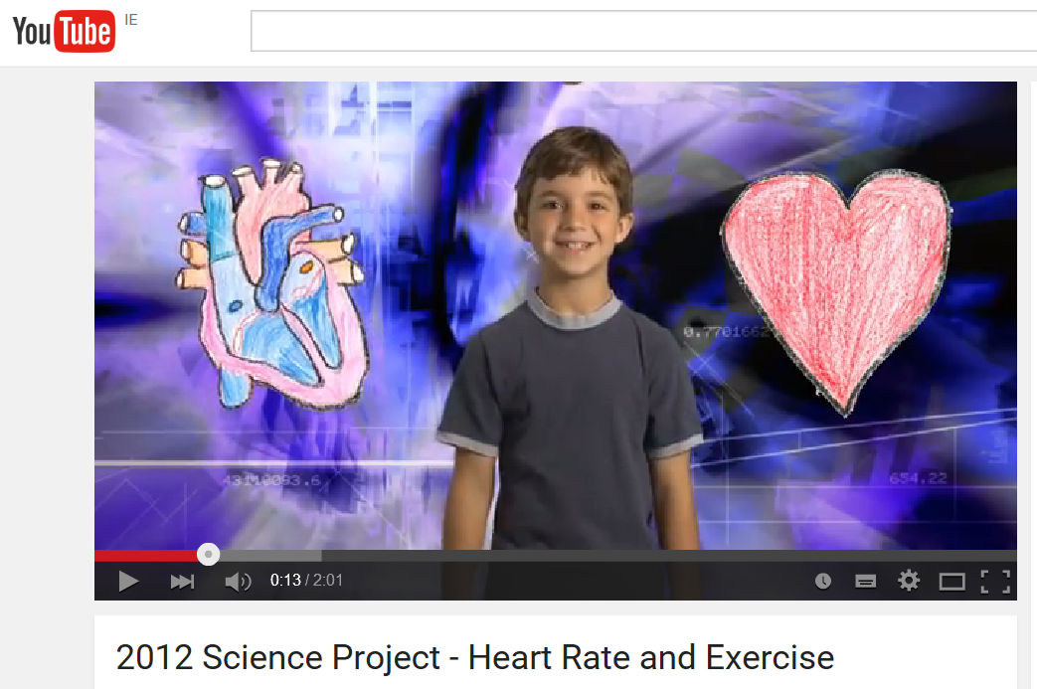](https://www.youtube.com/watch?v=BSPy4p20k4g)

[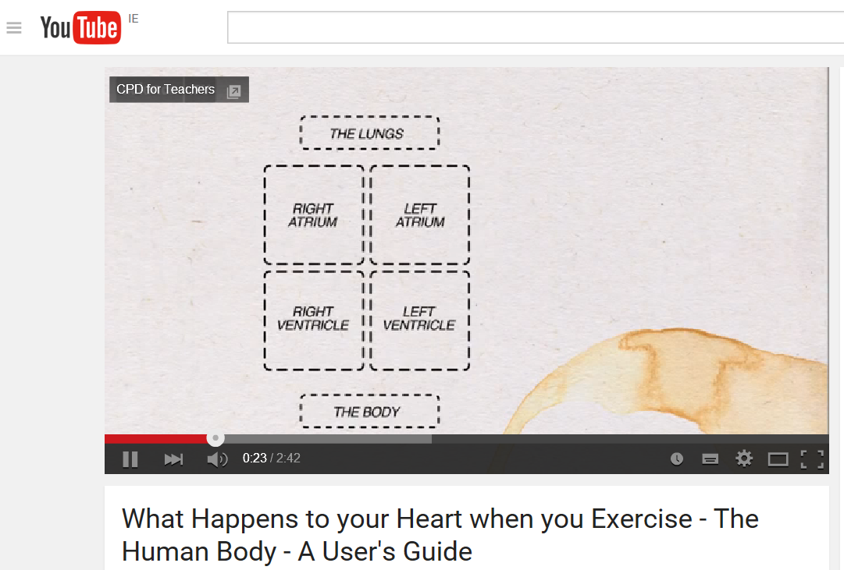](https://www.youtube.com/watch?v=O8ttt3M8qZM)

[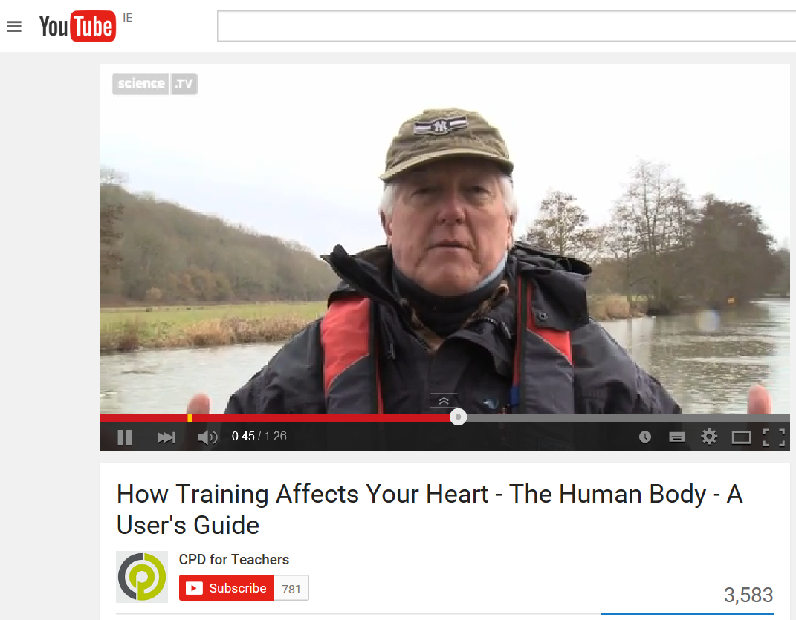](https://www.youtube.com/watch?v=8XGON2jzRe0)

[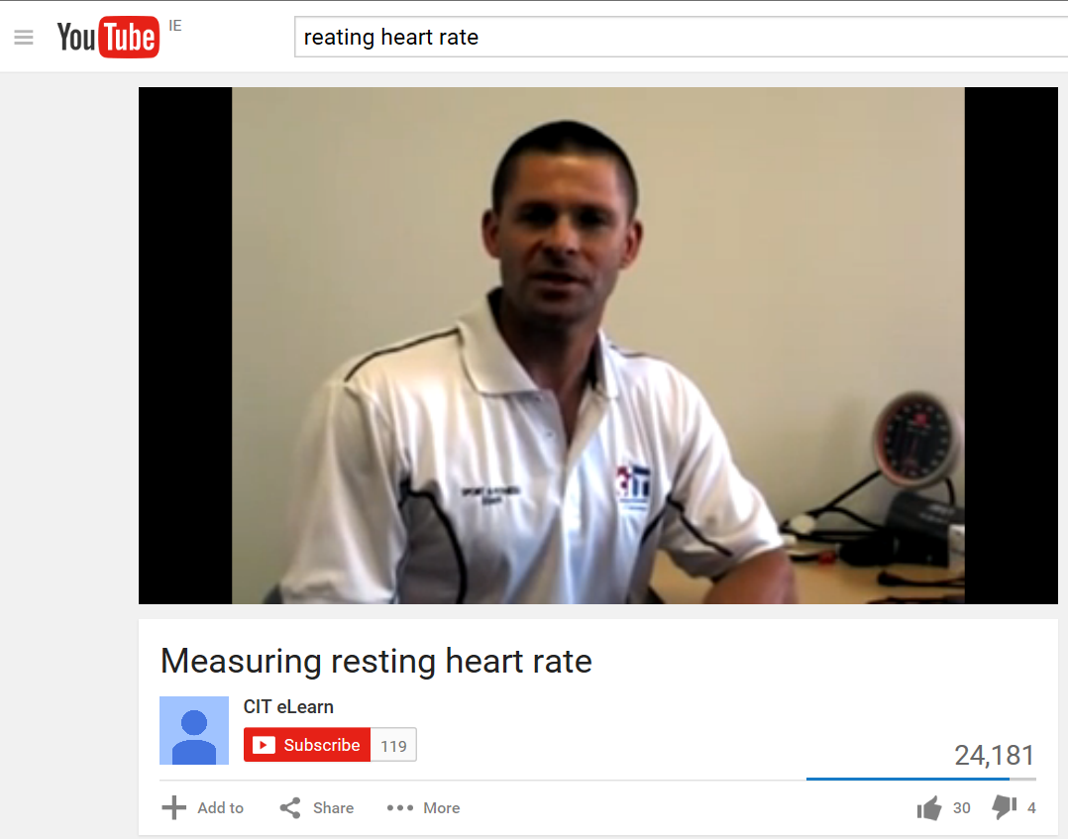](https://www.youtube.com/watch?v=qPKVfT5L4X8)

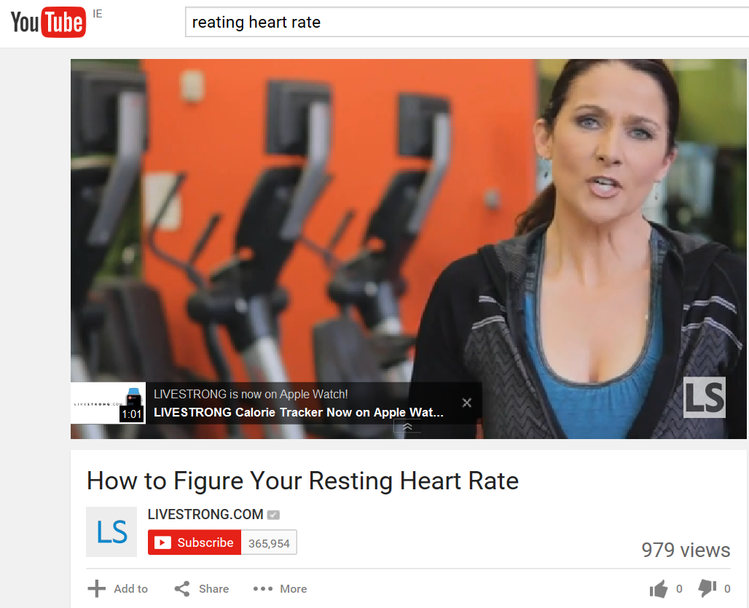

[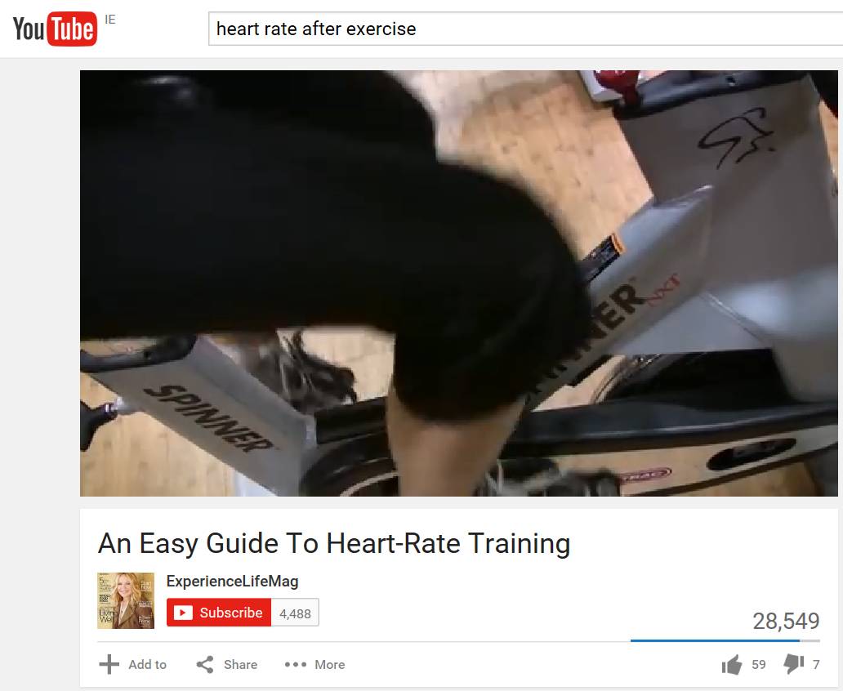](https://www.youtube.com/watch?v=NqGMHjkZqE8)